<https://www.youtube.com/watch?v=LsK-xG1cLYA&list=PLblh5JKOoLUICTaGLRoHQDuF_7q2GfuJF&index=49>

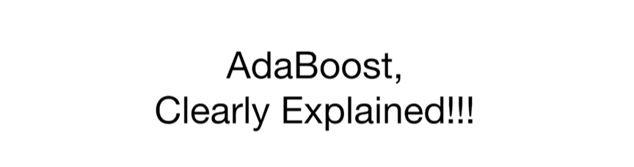

Today we're gonna cover adaboost and it's gonna be clearly explained.

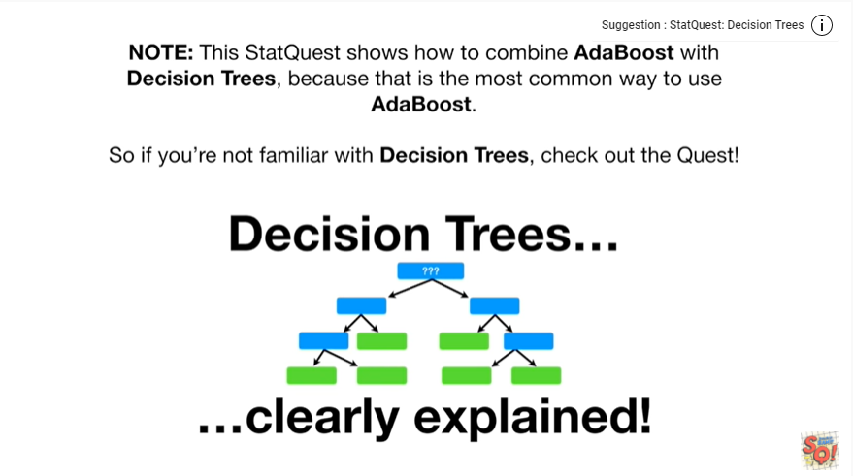

Note : this stack quest shows how to combine adaboost with decision trees because that is the most common way to use adaboost.

So if you're not familiar with decision trees, check out the quest.

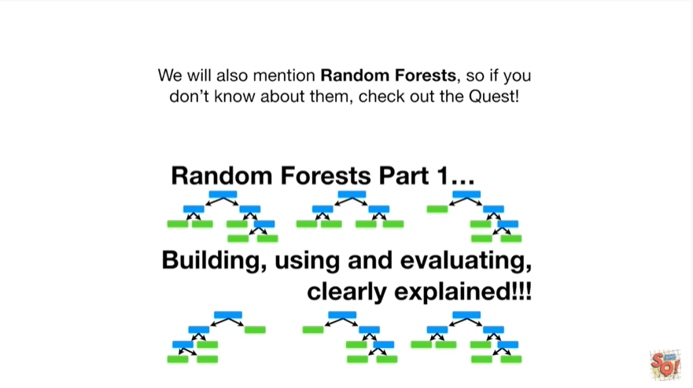

We will also mention random forests, so if you don't know about them, check out the quest !

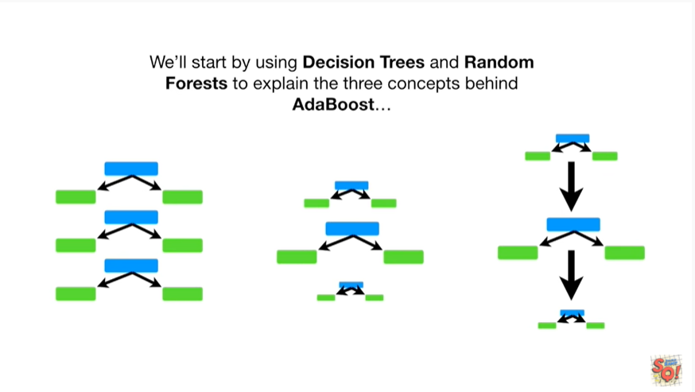

We'll start by using decision trees and random forests to explain the three concepts behind adaboost

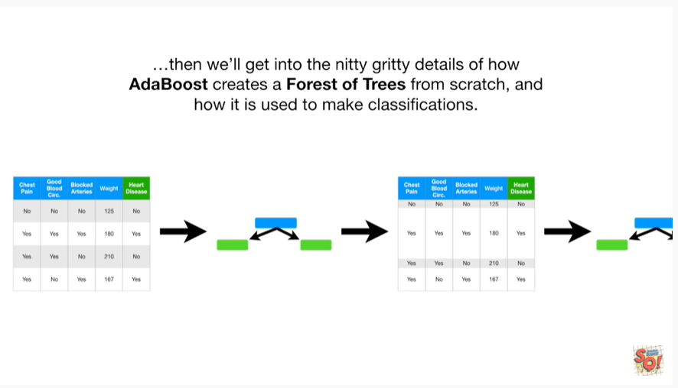

then we'll get into the nitty-gritty details of how adaboost creates a forest of trees from scratch, and how it's used to make classifications.

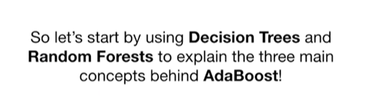

So let's start by using decision trees and random forests to explain the three main concepts behind adaboost !

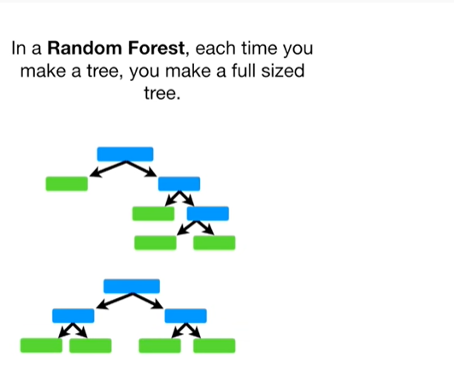

In a random forest each time you make a tree you make a full-sized tree.

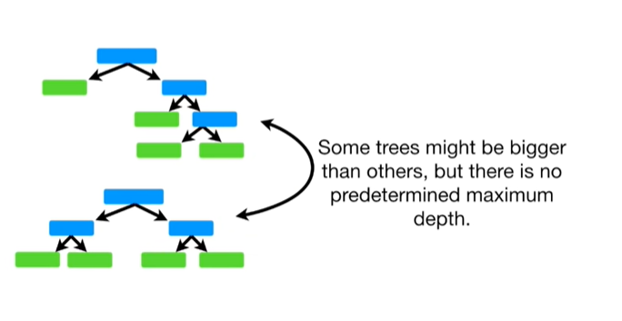

Some trees might be bigger than others but there's no predetermined maximum depth.

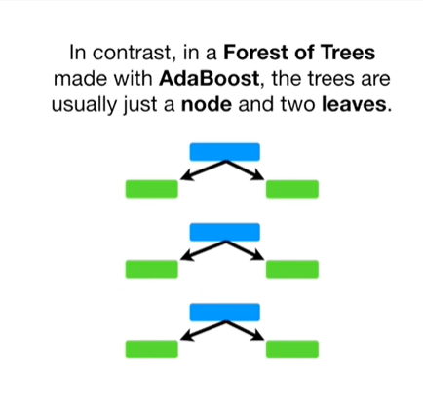

In contrast, in a forest of trees made with adaboost, the trees are usually just a node and two leaves.

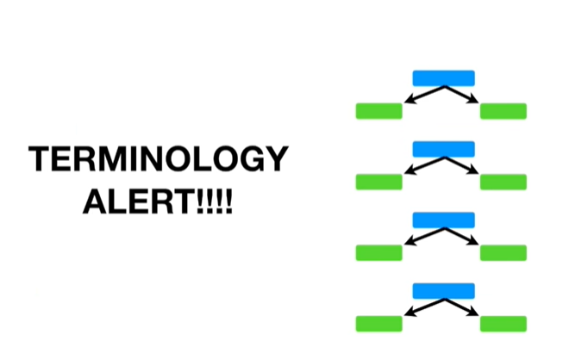

Oh no, it's the dreaded terminology alert.

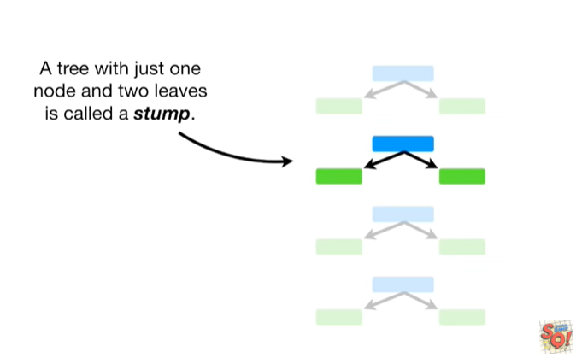

A tree with just one node and two leaves is called a stump

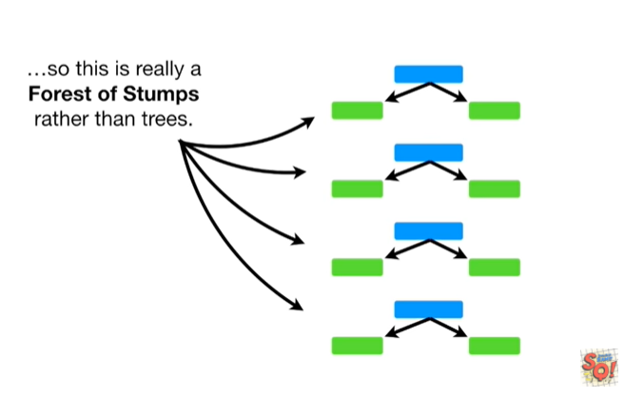

so this is really a forest of stumps rather than trees.

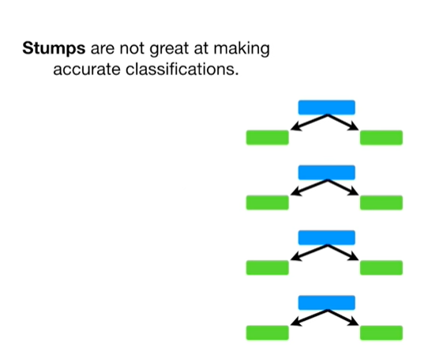

Stumps are not great at making accurate classifications.

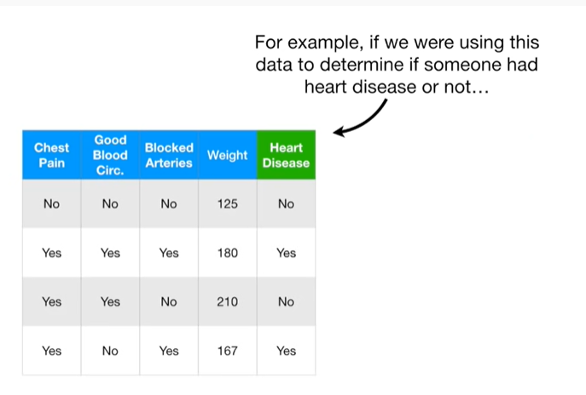

For example, if we were using this data to determine if someone had heart disease or not

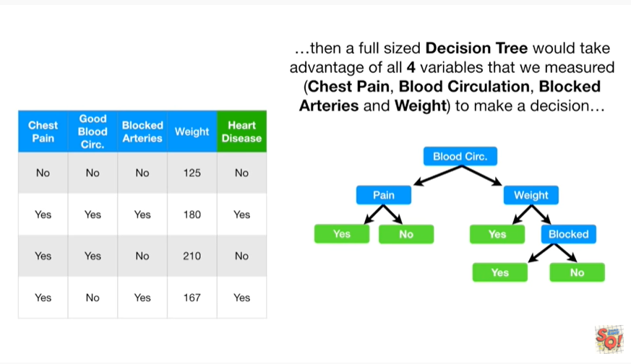

then a full-size decision tree would take advantage of all four variables that we measured (chest pain, blood circulation, blocked arteries and weight) to make a decision

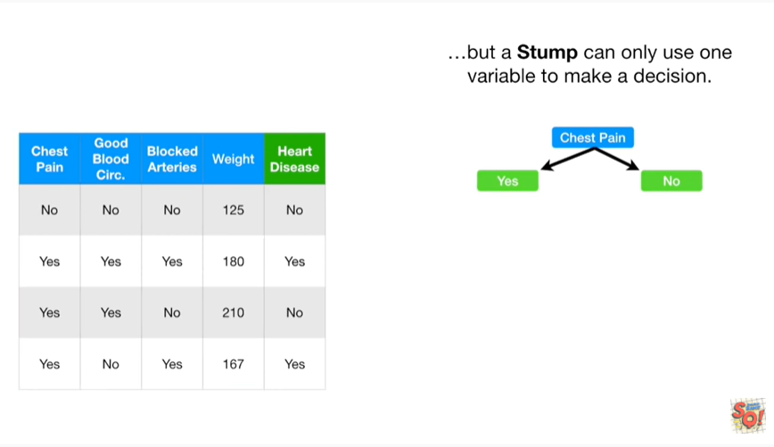

but a stump can only use one variable to make a decision.

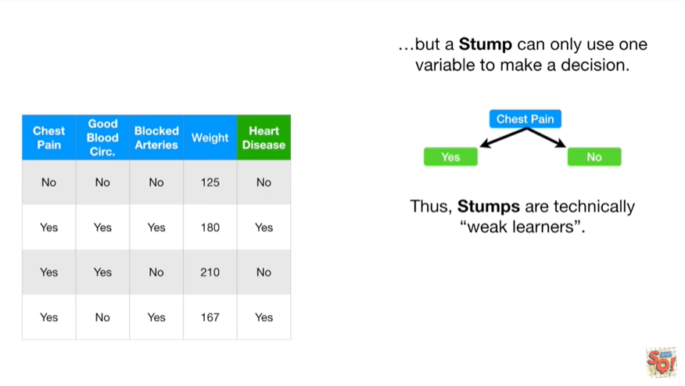

Thus, stumps are technically weak learners.

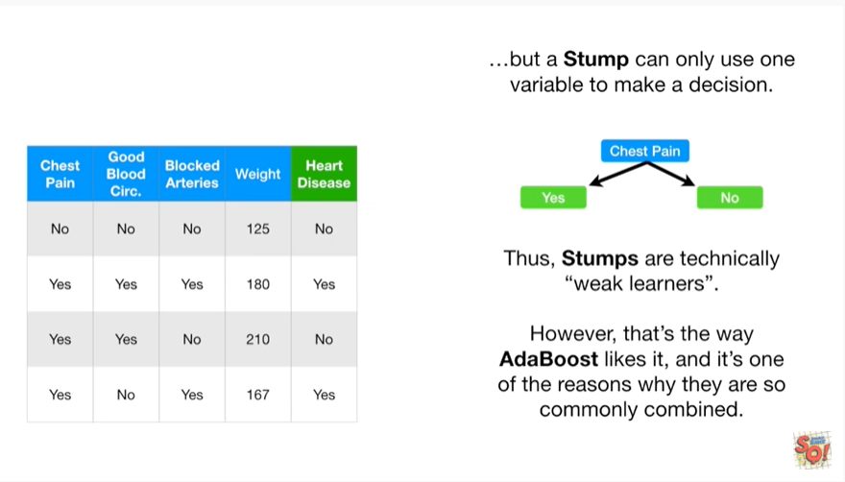

However, that's the way adaboost likes it, and it's one of the reasons why they are so commonly combined.

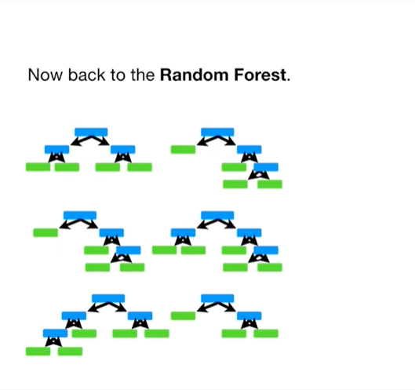

Now back to the random forest.

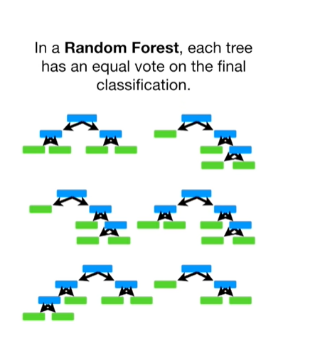

In a random forest each tree has an equal vote on the final classification.

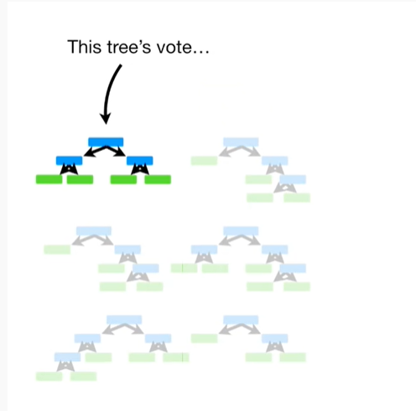

This trees vote

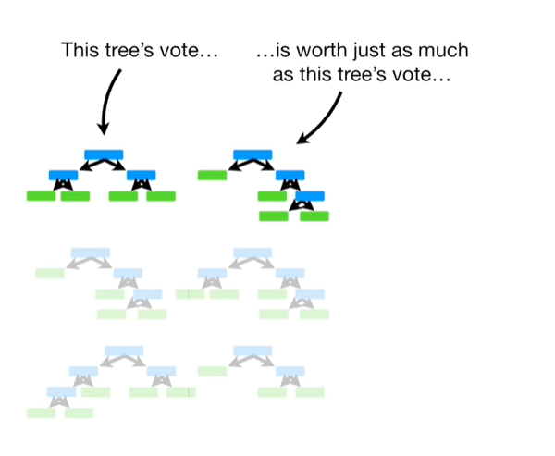

is worth just as much as this trees vote

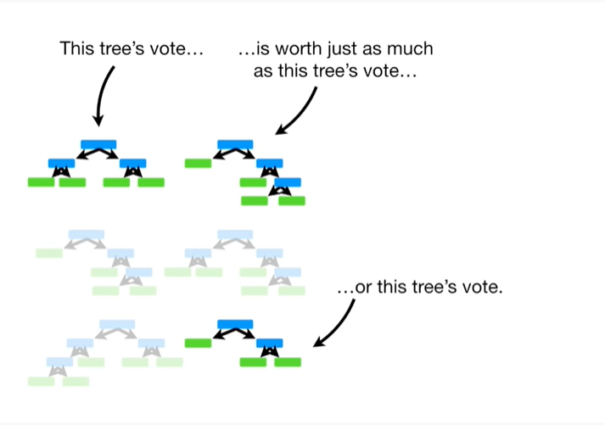

or this trees vote.

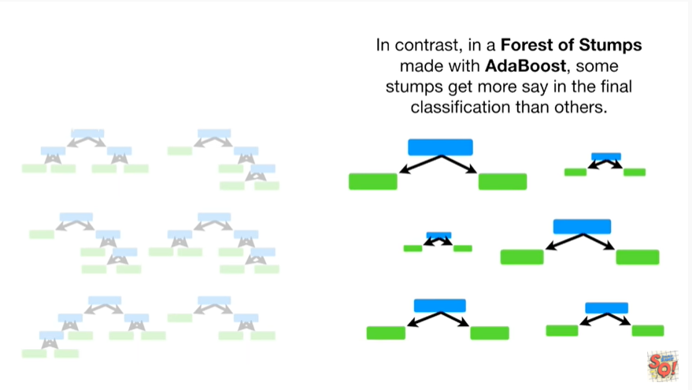

In contrast, in a forest of stumps made with adaboost, some stumps get more say in the final classification than others.

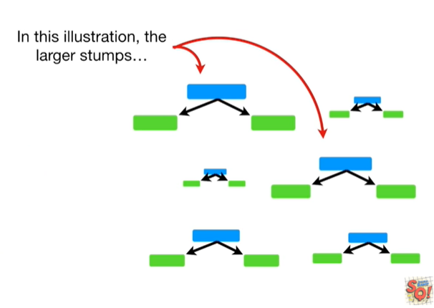

In this illustration the larger stumps

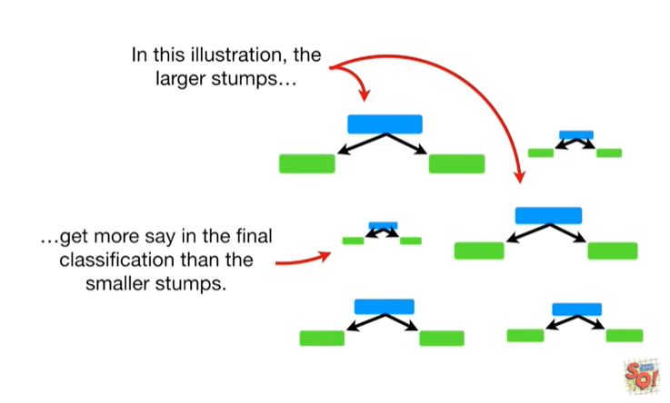

get more say in the final classification than the smaller stumps.

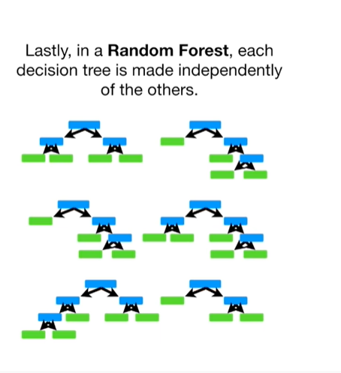

Lastly in a random forest each decision tree is made independently of the others.

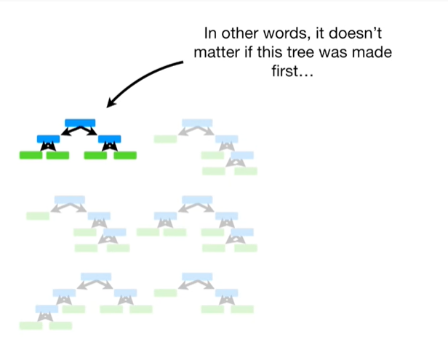

In other words, it doesn't matter if this tree was made first

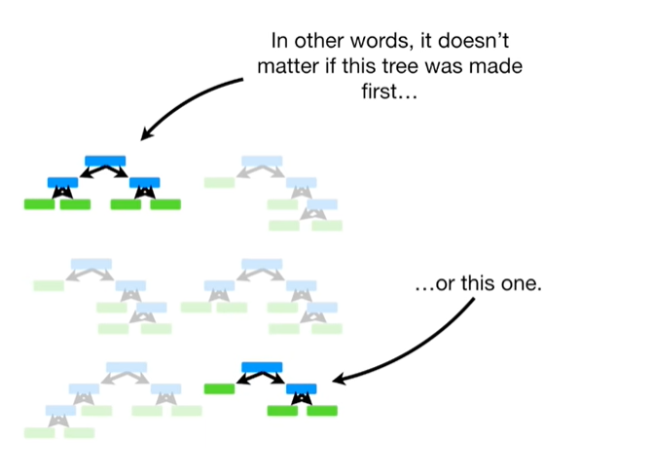

or this one.

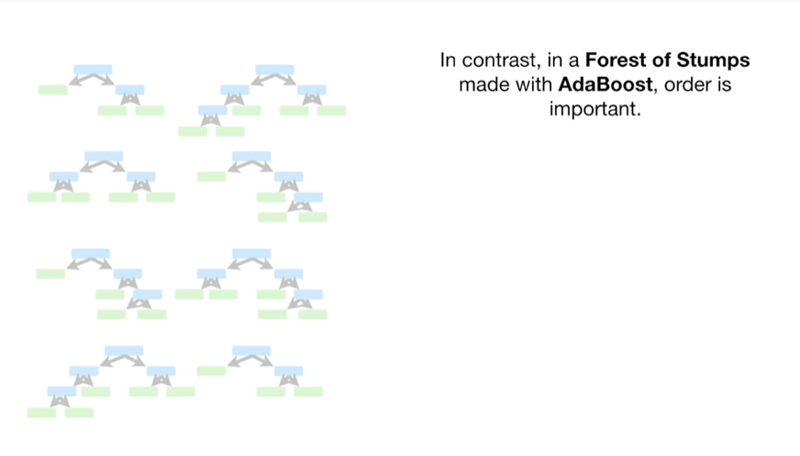

In contrast, in a forest of stumps made with adaboost, order is important.

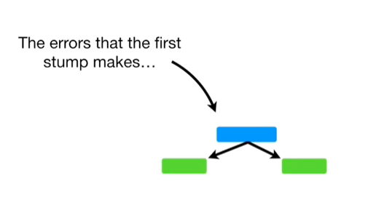

The errors that the first stump makes

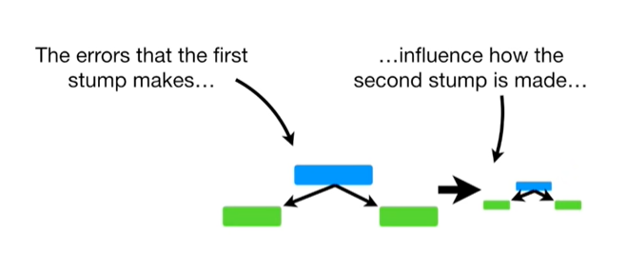

influence how the second stump is made

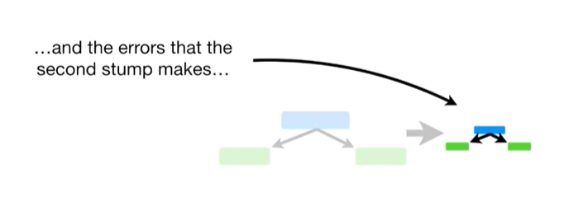

and the errors that the second stone makes

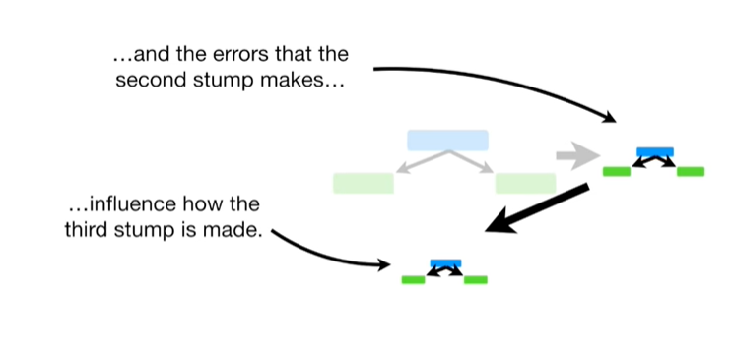

influence how the third stump is made

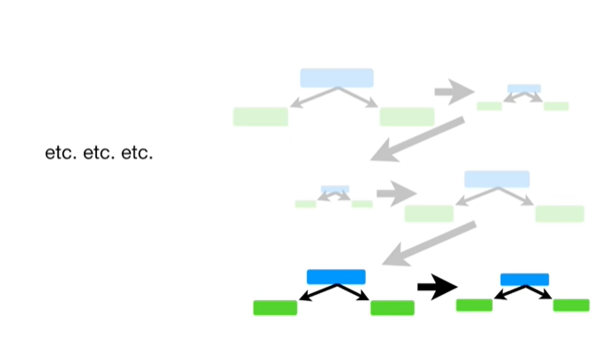

Etc etc etc…

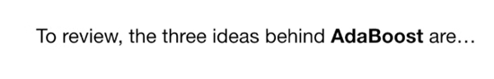

To review, the three ideas behind adaboost are :

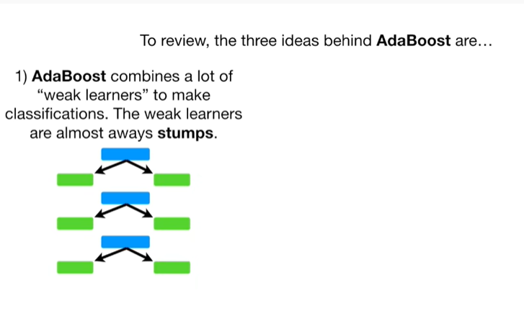

1. Adaboost combines a lot of week learners to make classifications.

The week learners are almost always stumps.

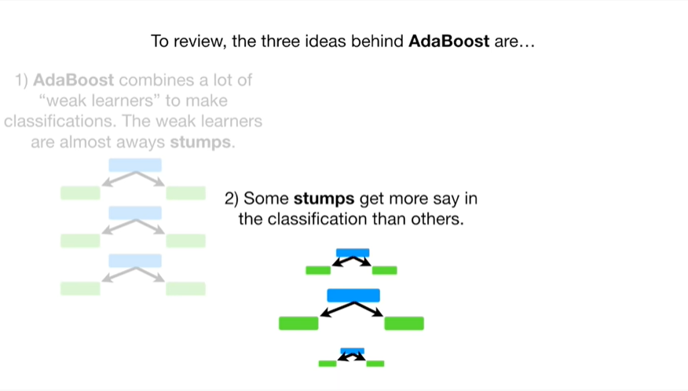

2. Some stumps get more say in the classification than others.

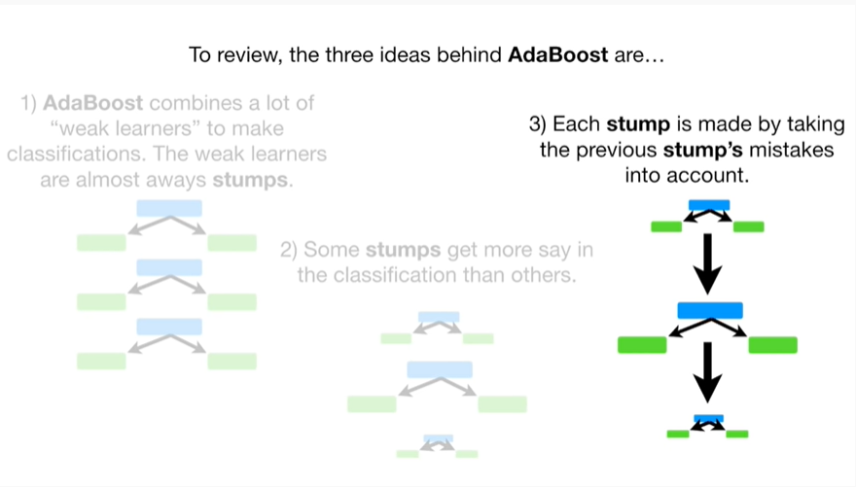

3. Each stump is made by taking the previous stumps mistakes into account.

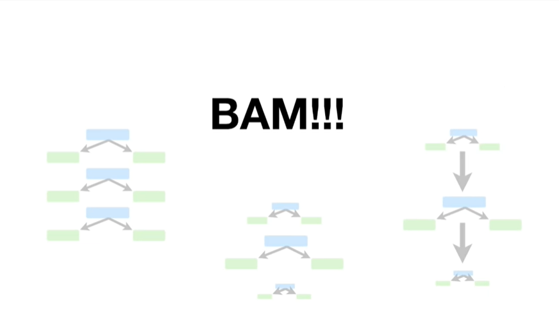

BAM !!!

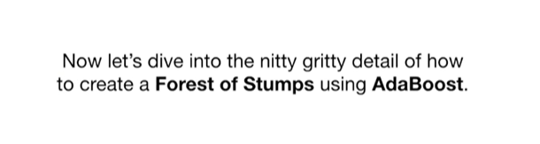

Now, let’s dive into the nitty-gritty detail of how to create a forest of stumps using adaboost.

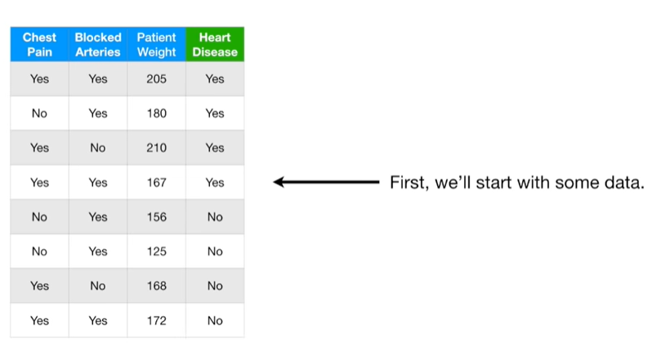

First we'll start with some data.

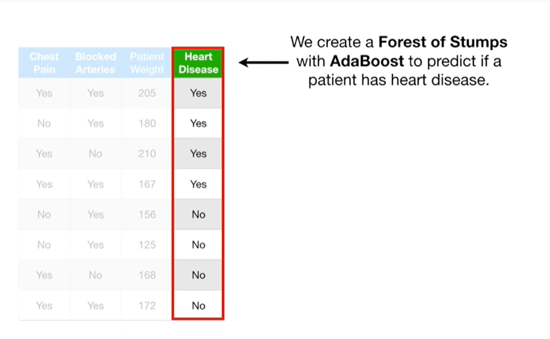

We create a forest of stumps with adaboost to predict if a patient has heart disease.

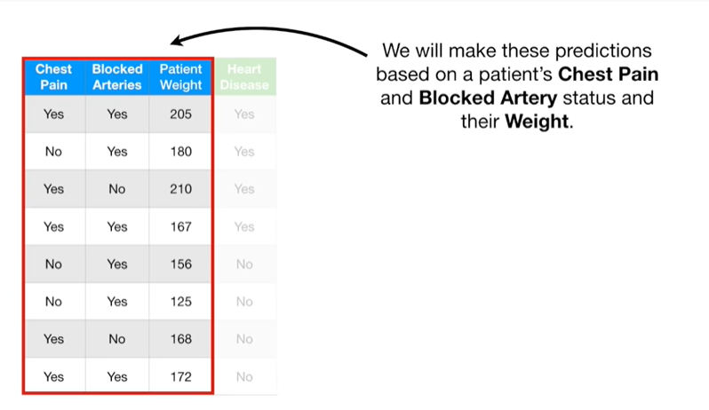

We will make these predictions based on a patient's chest pain and blocked artery status and their weight.

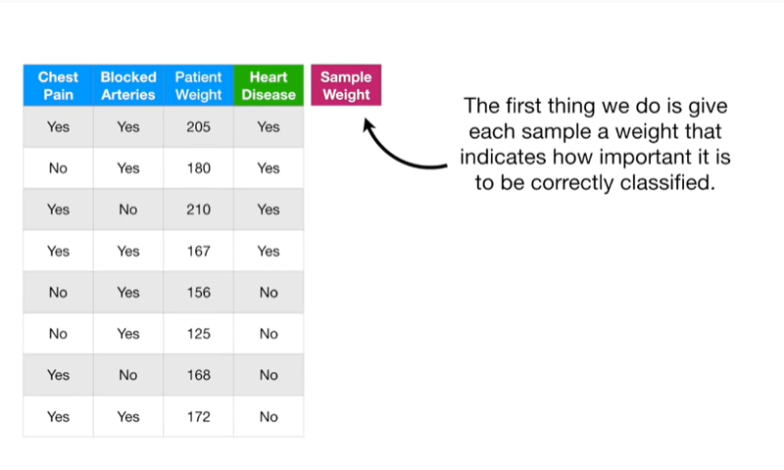

The first thing we do is give each sample a weight that indicates how important it is to be correctly classified.

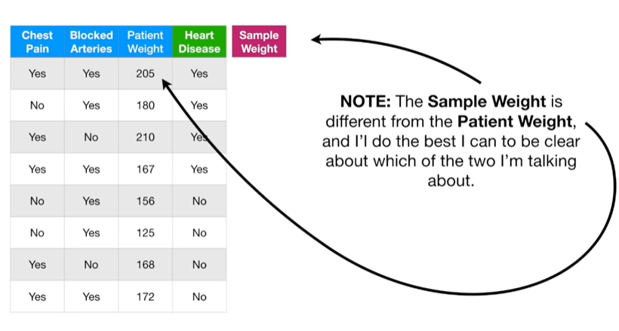

Note : the sample weight is different from the patient weight and I'll do the best I can to be clear about which of the two I'm talking about.

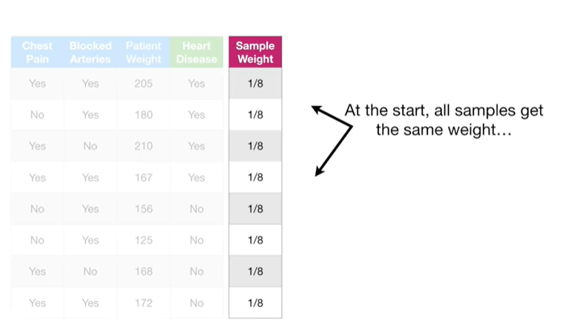

At the start all samples get the same weight

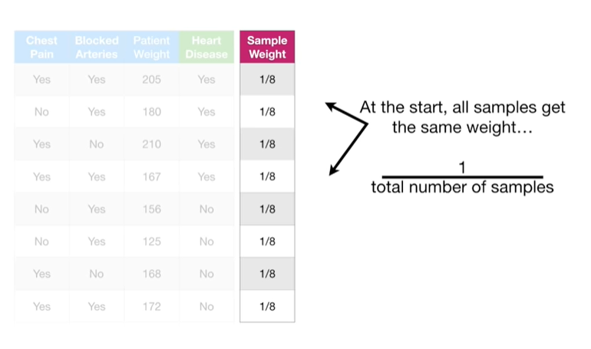

one divided by the total number of samples.

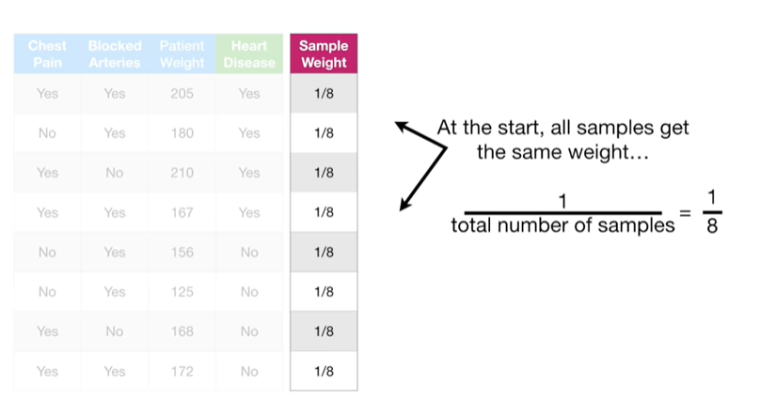

In this case that's 1/8

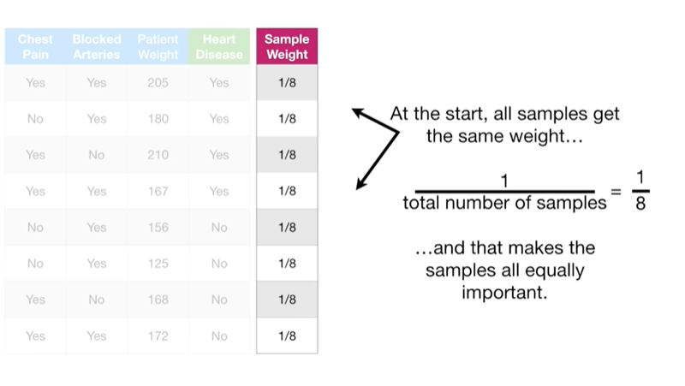

and that makes the samples all equally important.

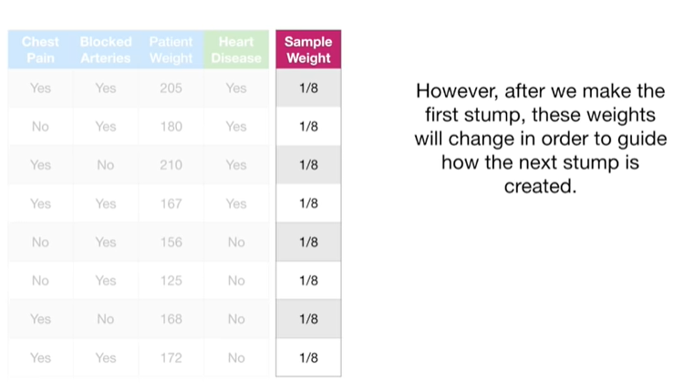

However, after we make the first stump, these weights will change in order to guide how the next stump is created.

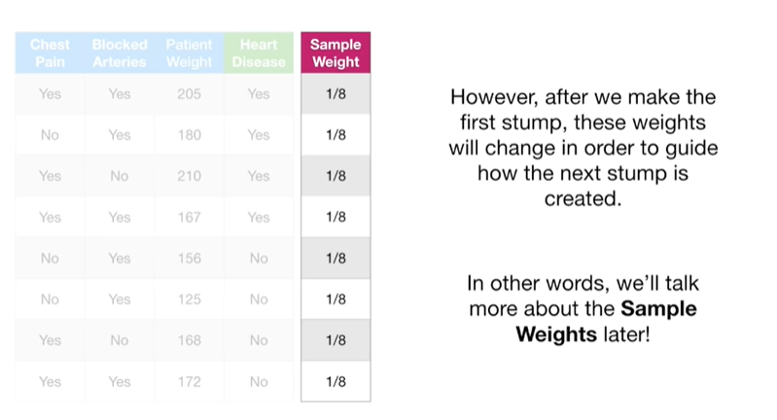

In other words, we'll talk more about the sample weights later !

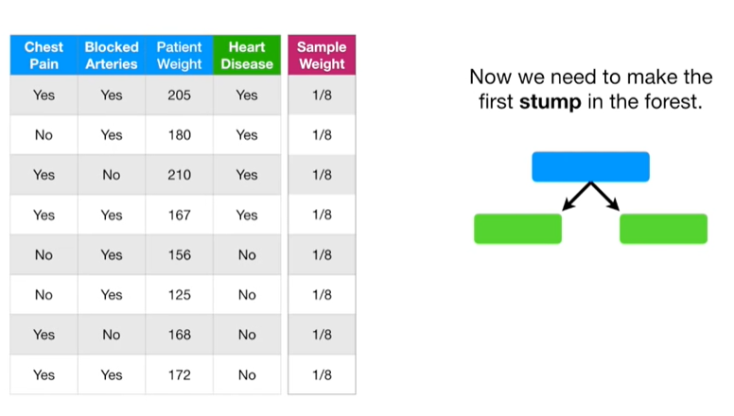

Now we need to make the first stump in the forest.

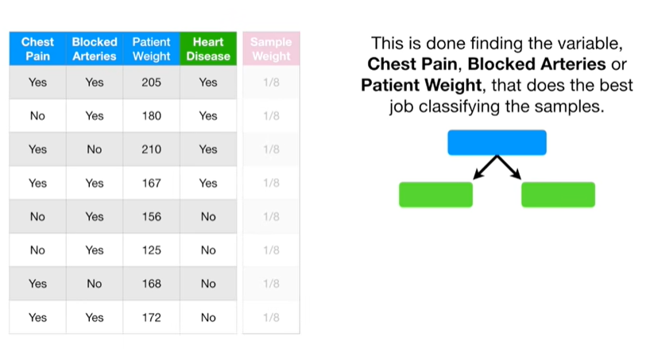

This is done by finding the variable

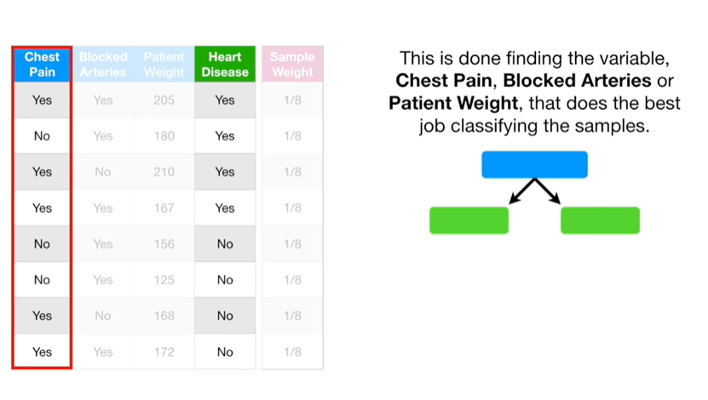

chest pain

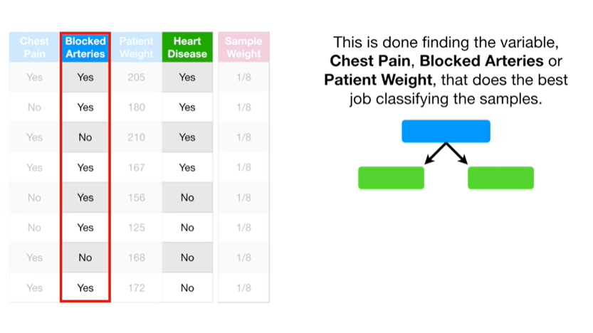

blocked arteries

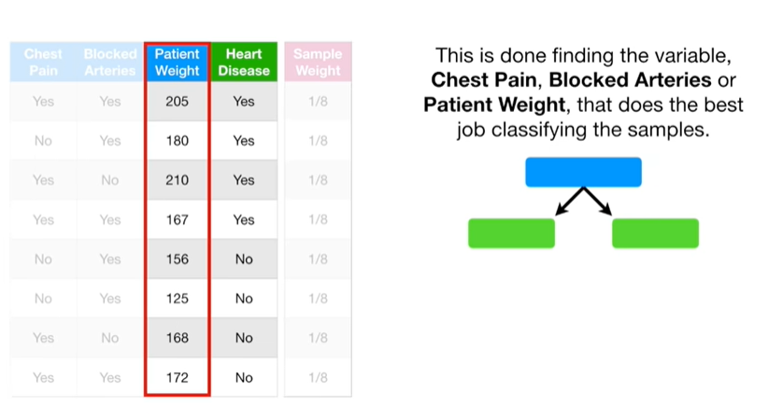

or patient weight that does the best job classifying the samples.

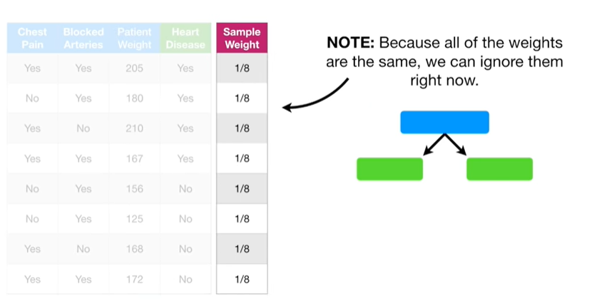

Note : because all of the weights are the same we can ignore them right now.

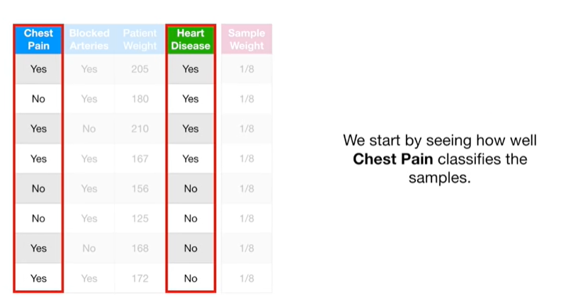

We start by seeing how well chest pain classifies the samples.

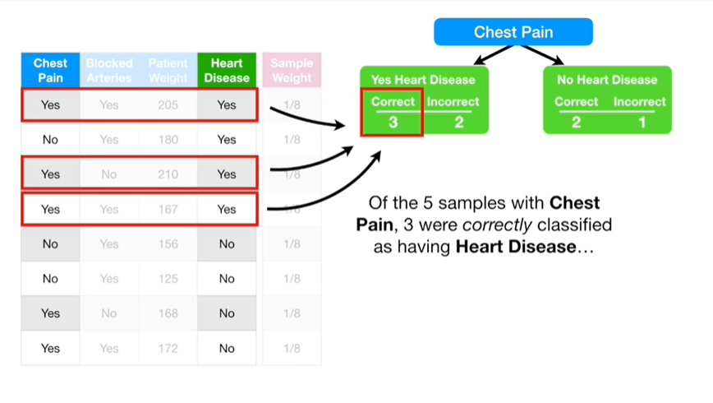

Of the five samples with chest pain, three were correctly classified as having heart disease

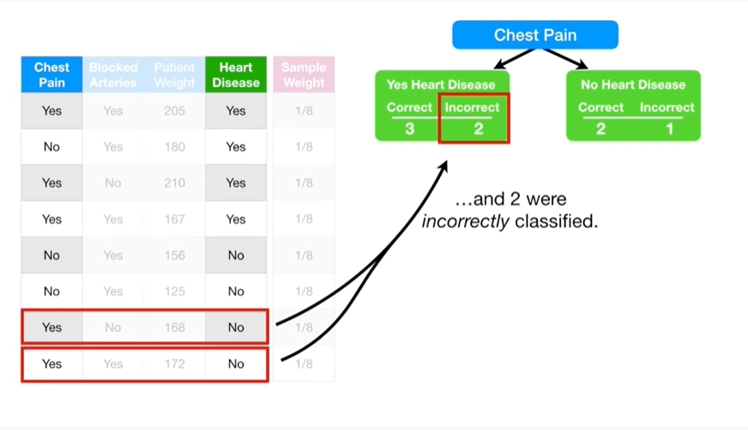

and two were incorrectly classified.

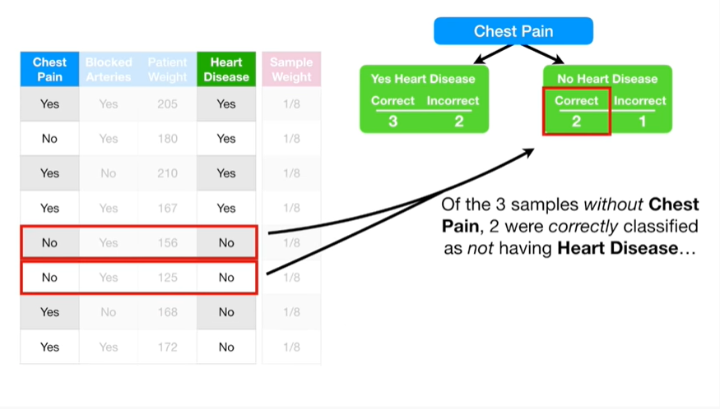

Of the three samples without chest pain, two were correctly classified as not having heart disease

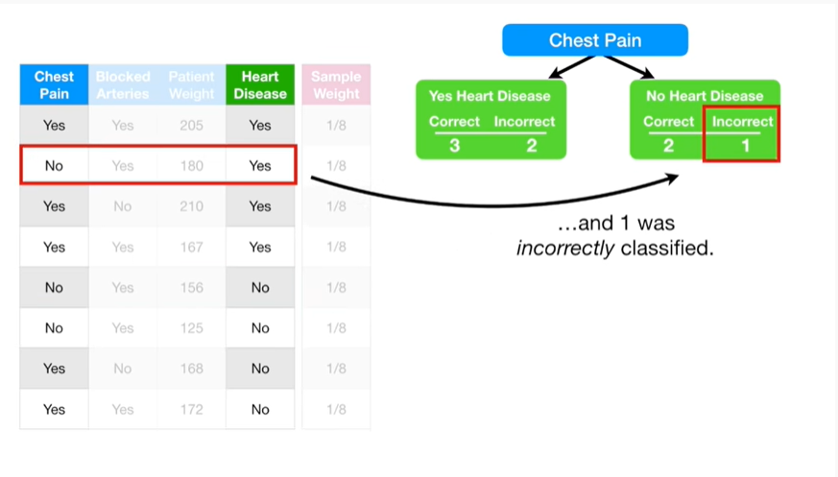

and one was incorrectly classified.

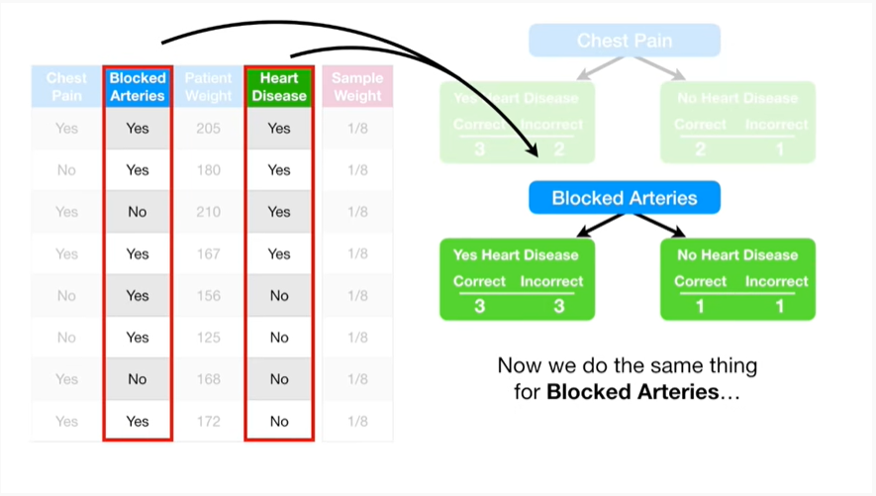

Now we do the same thing for blocked arteries

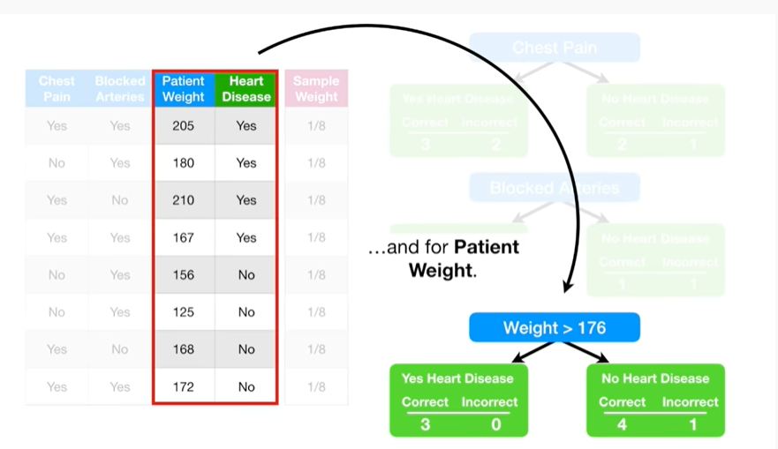

and for patient weight.

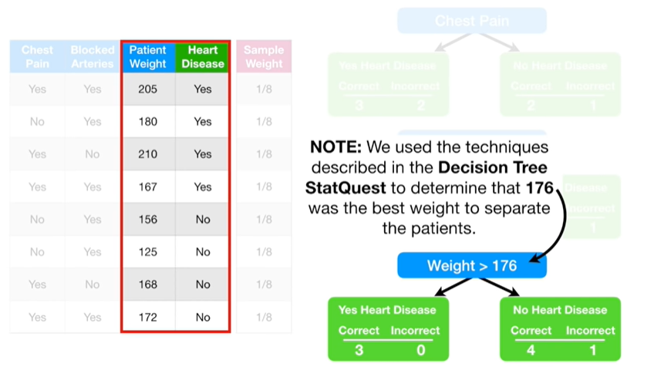

Note : we used the techniques described in the decision tree stat quest to determine that 176 was the best weight to separate the patients.

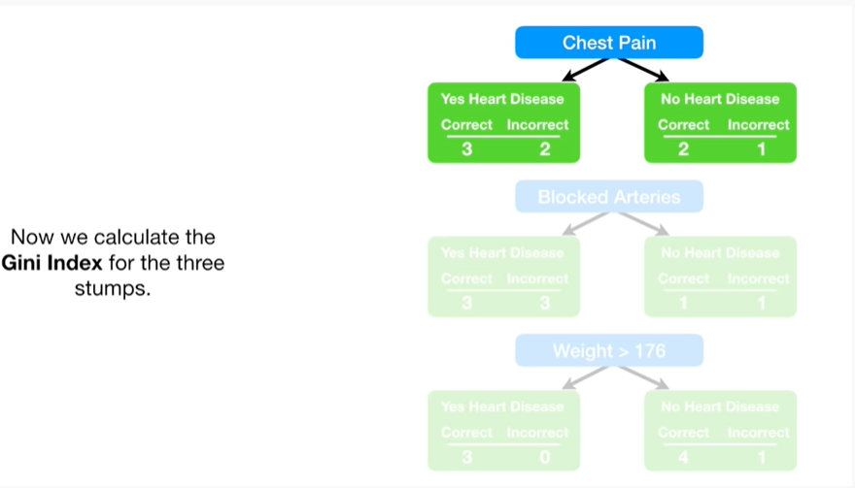

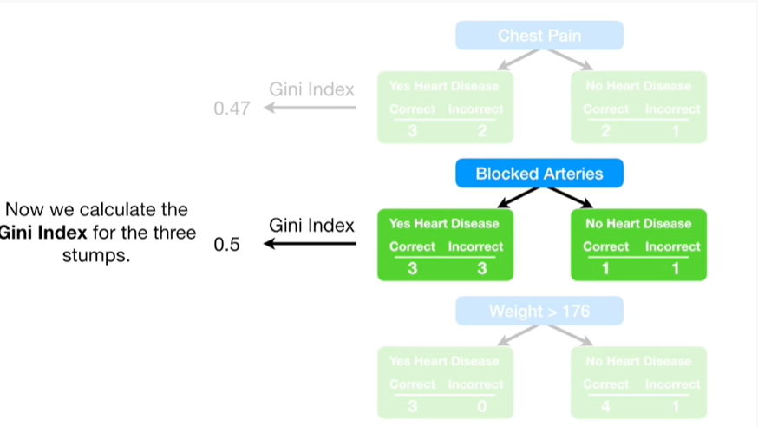

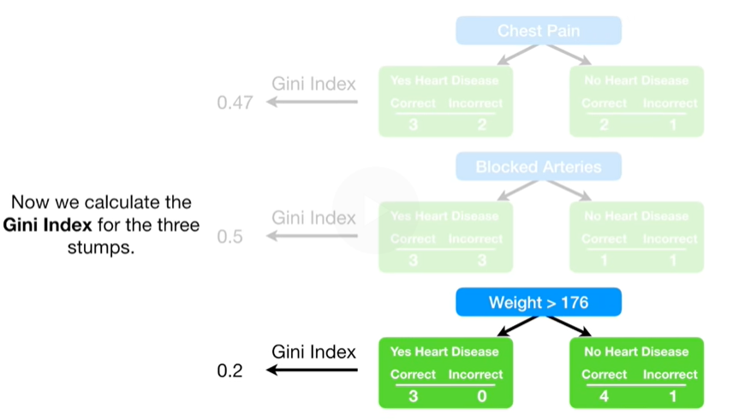

Now we calculate the Gini index for the three stumps.

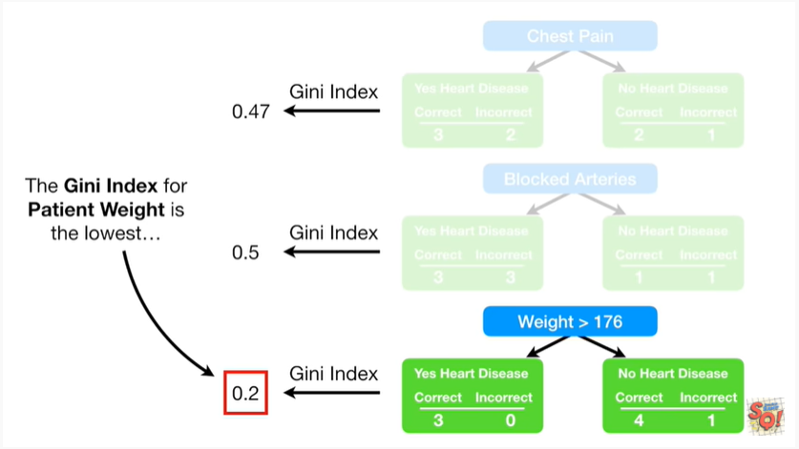

The Gini index for patient weight is the lowest

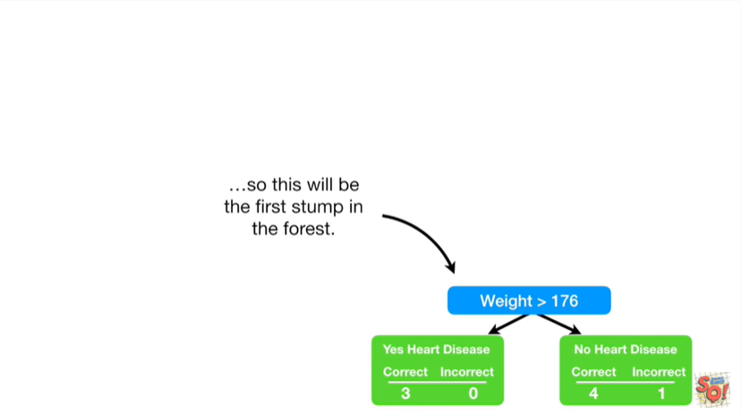

so this will be the first stump in the forest.

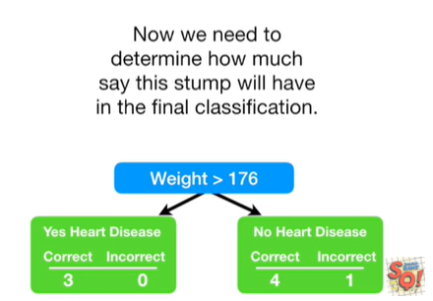

Now we need to determine how much say this stump will have in the final classification.

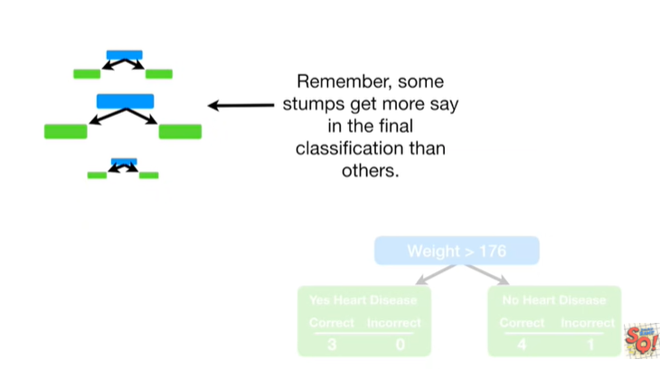

Remember some stumps get more say in the final classification than others.

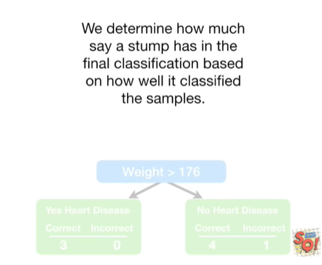

We determine how much say a stump has in the final classification based on how well it classified the samples.

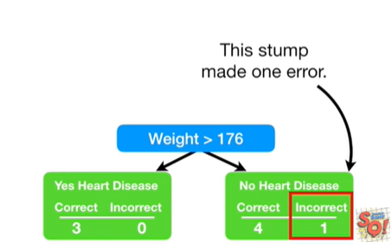

This stump made one error.

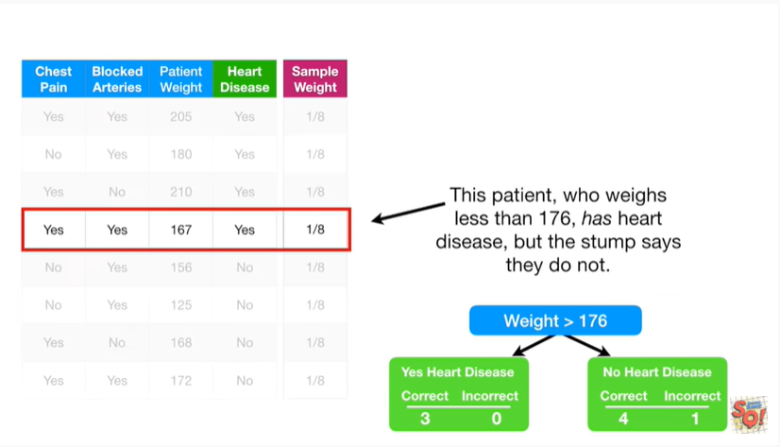

This patient who weighs less than 176 has heart disease but the stump says they do not the total.

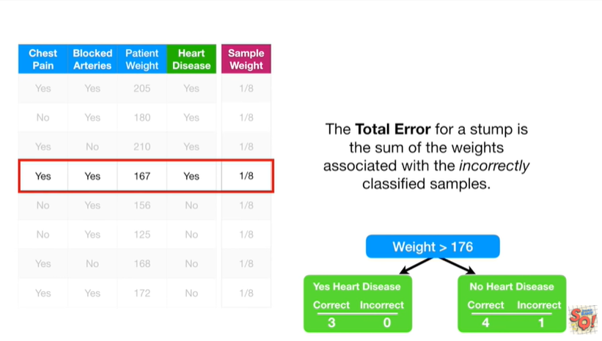

The total error for a stump is the sum of the weights associated with the incorrectly classified samples.

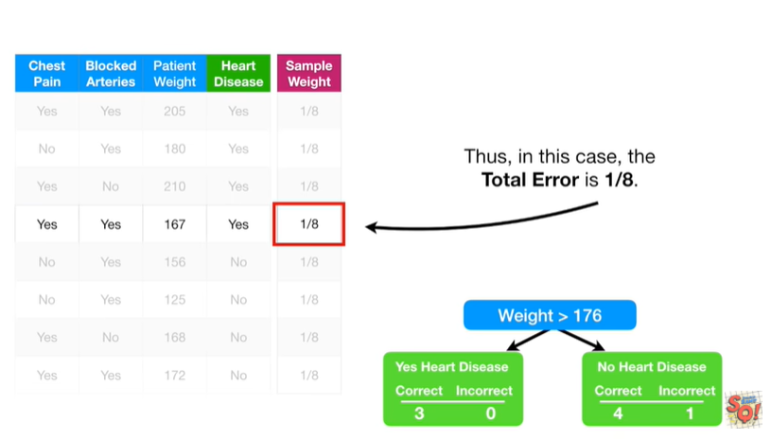

Thus, in this case, the total error is 1/8.

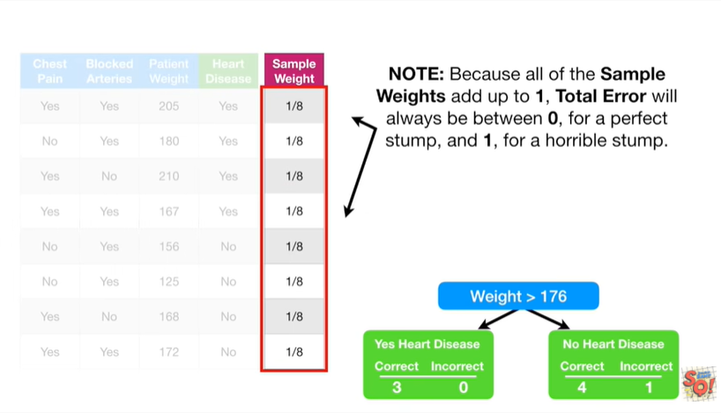

Note : because all of the sample weights add up to one, total error will always be between zero for a perfect stump and one for a horrible stump.

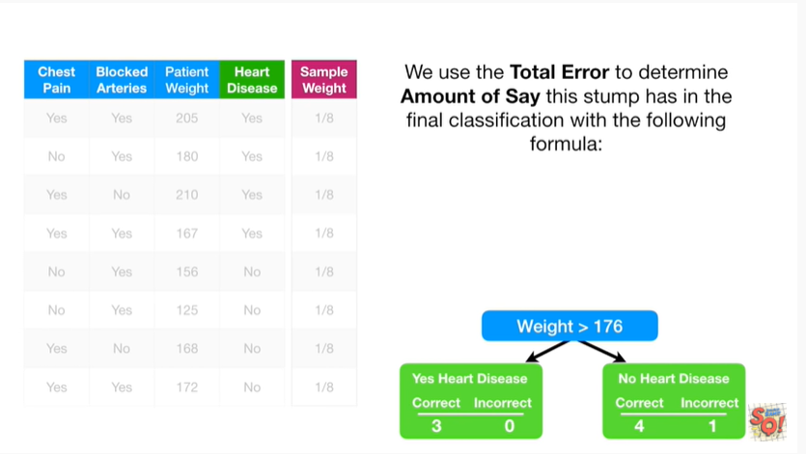

We use the total error to determine the amount of say this stump has in the final classification with the following formula :

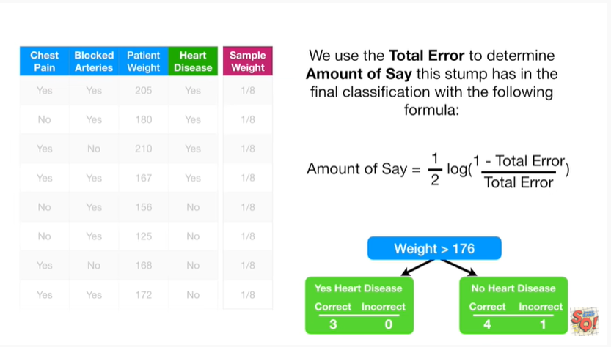

amount of say equals 1/2 times the log of 1 minus the total error divided by the total error.

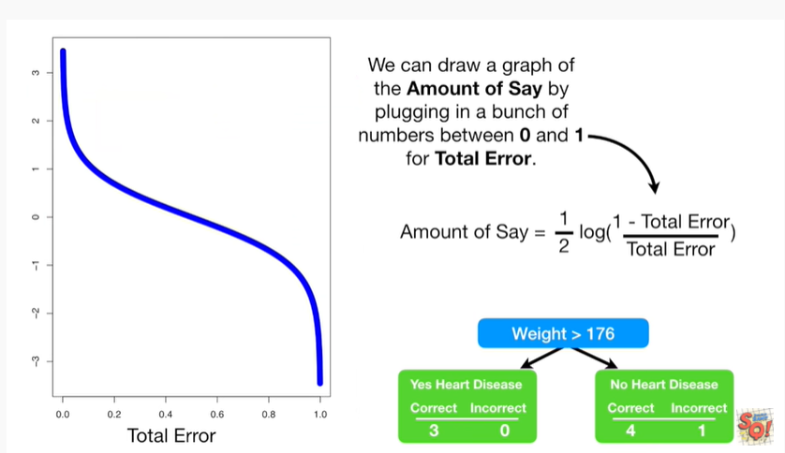

We can draw a graph of the amount of say by plugging in a bunch of numbers between 0 & 1 for total error.

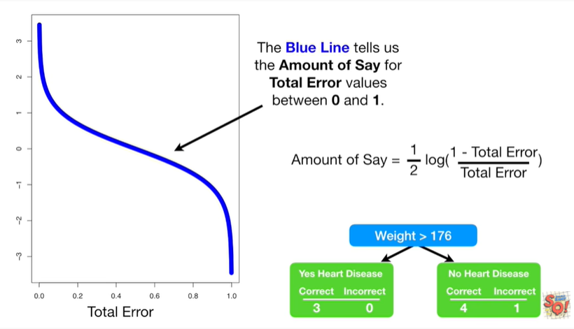

The blue line tells us the amount of safe for total error values between 0 & 1.

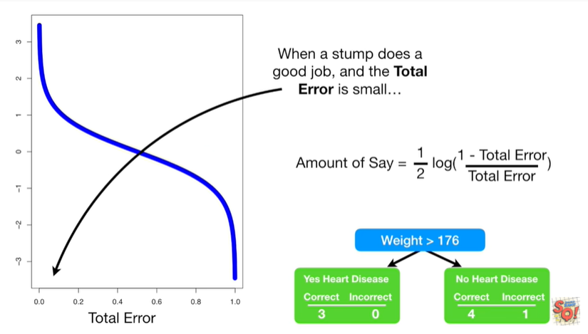

When a stump does a good job and the total error is small

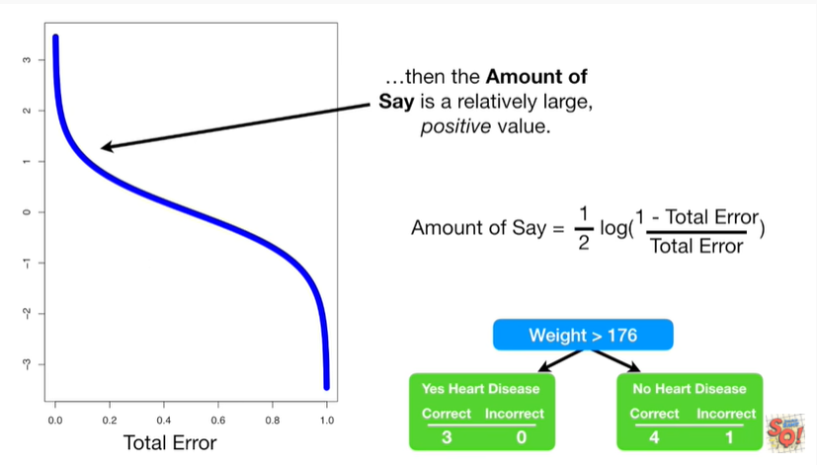

then the amount of say is a relatively large positive value.

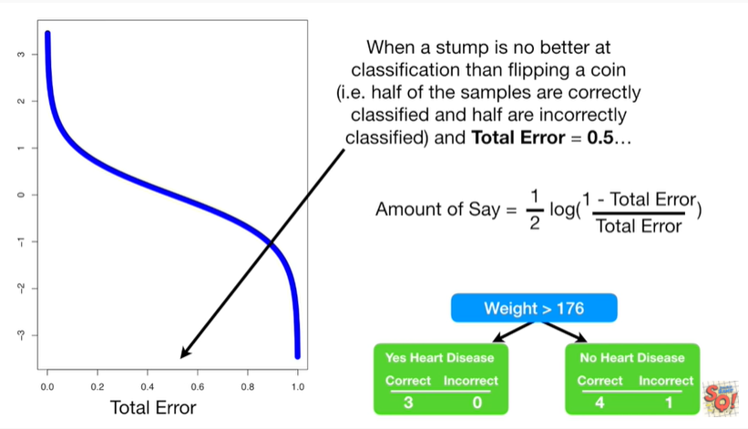

When a stump is no better at classification than flipping a coin (ie half the stumps are correctly classified and half are incorrectly classified) and the total error equals 0.5

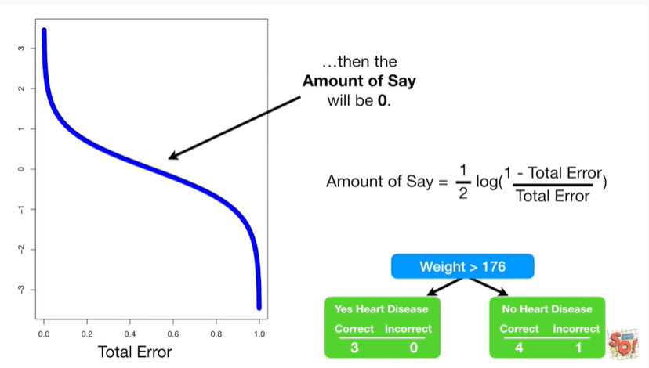

then the amount of say will be zero.

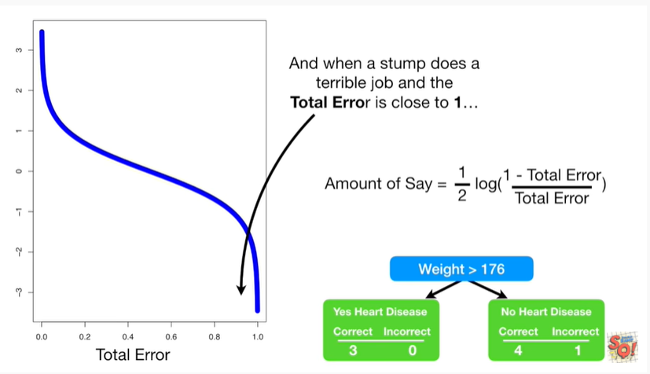

And when a stump does a terrible job and the total error is close to one

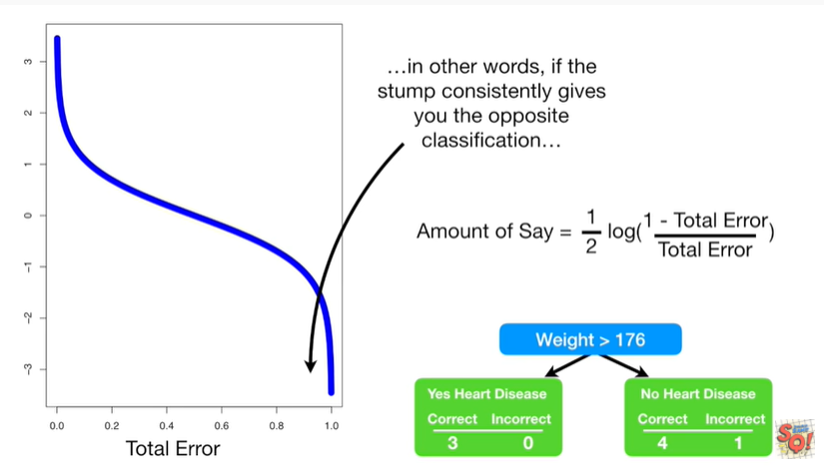

in other words if the stump consistently gives you the opposite classification

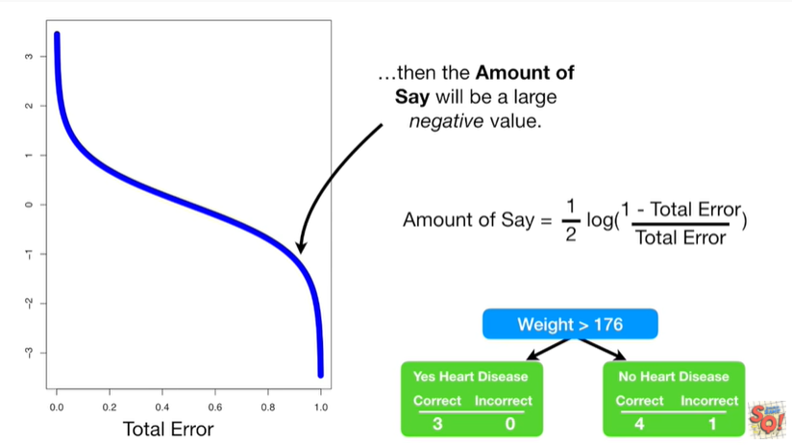

then the amount of say will be a large negative value.

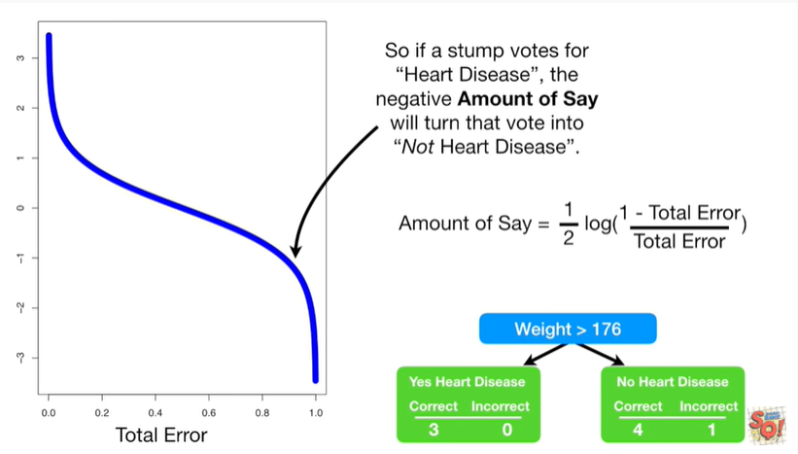

So if a stump votes for heart disease, the negative amount of say will turn that vote into not heart disease.

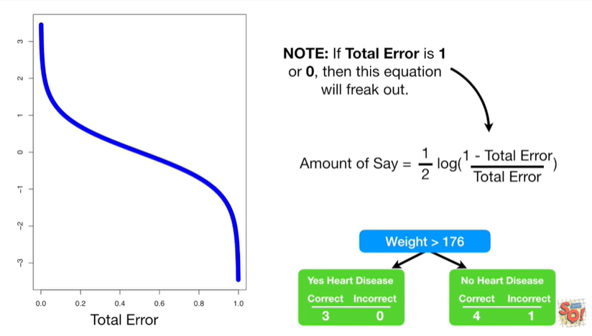

Note : if total error is 1 or 0 then this equation will freak out.

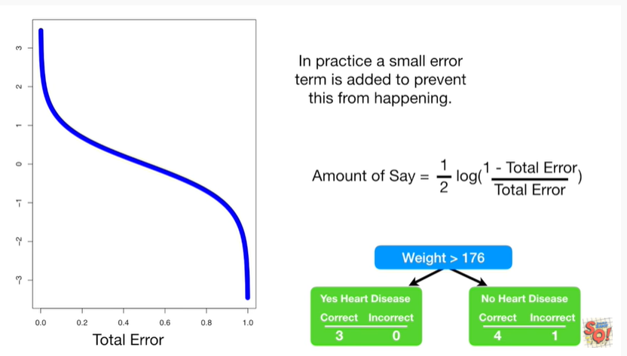

In practice, a small error term is added to prevent this from happening.

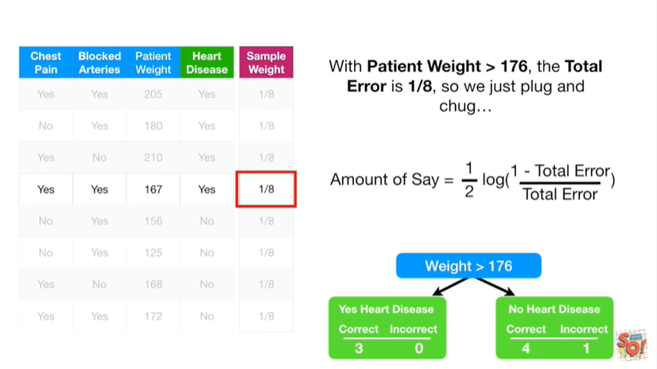

With patient weight greater than 176 the total error is 1/8

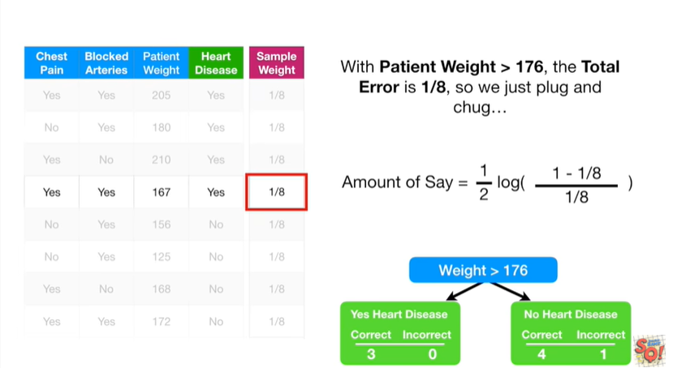

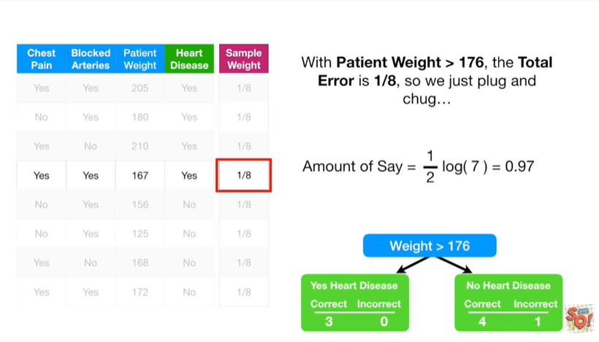

so we just plug and chug

booty today voodoo to pooh-poohed

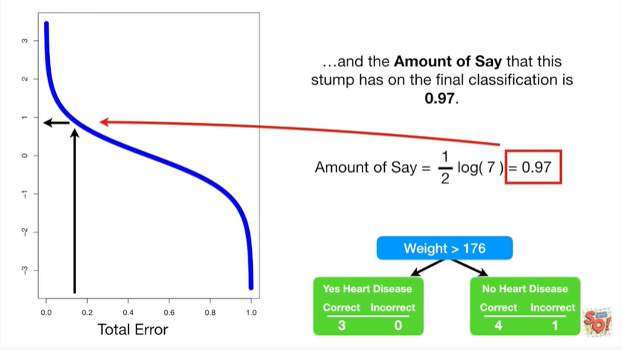

and the amount of say that this stump has in the final classification is zero point nine seven.

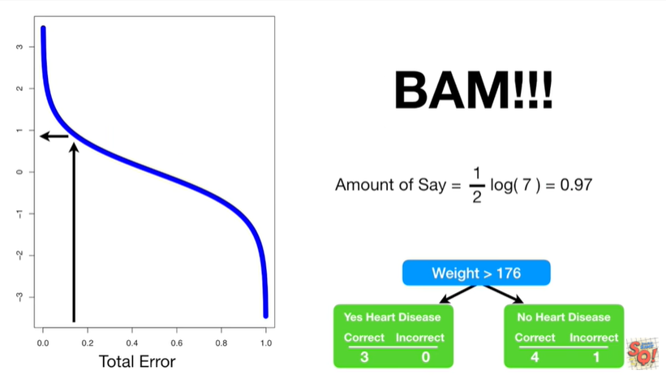

BAM !!!

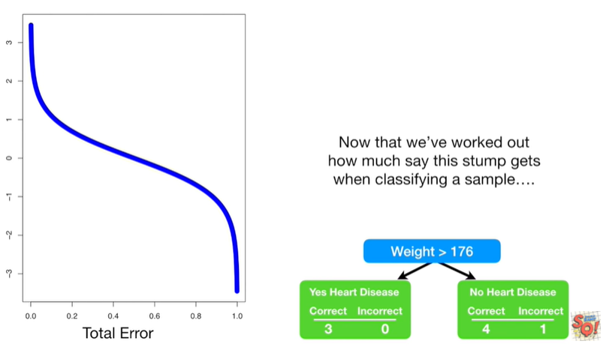

Now that we've worked out how much say this stump gets when classifying a sample

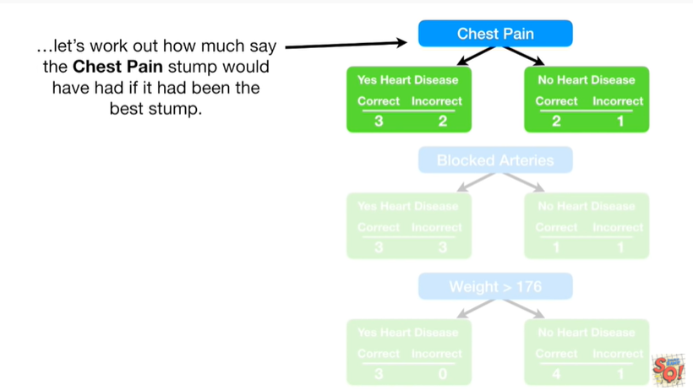

let's work out how much say the chest pain stump would have if it had been the best stump.

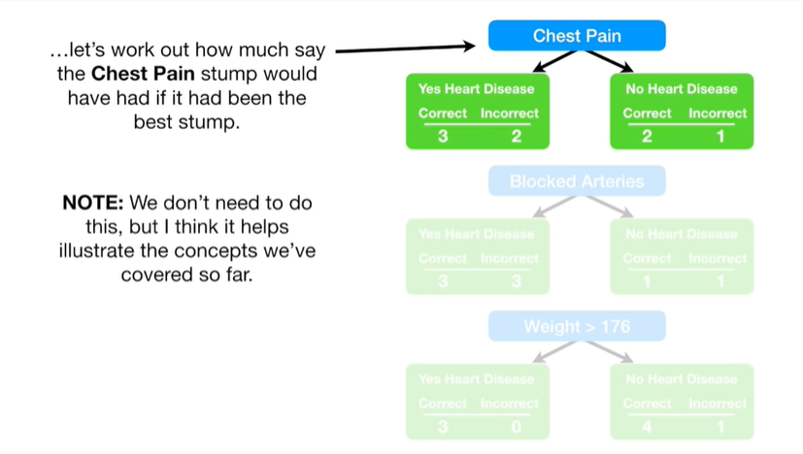

Note : we don't need to do this but I think it helps illustrate the concepts we've covered so far.

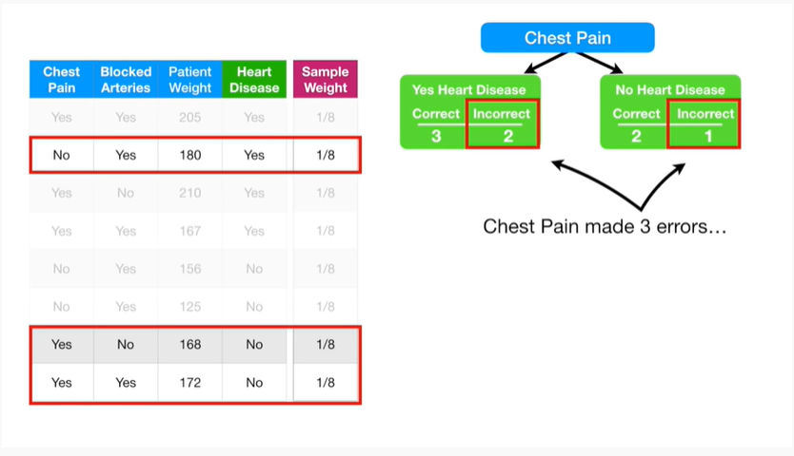

Chest pain made three errors

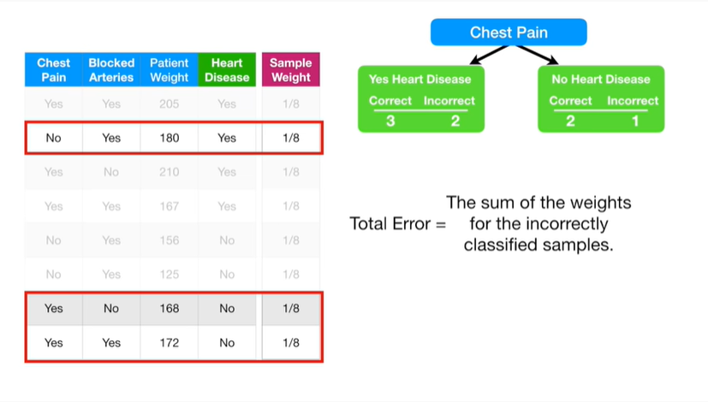

and the total error equals the sum of the weights for the incorrectly classified samples

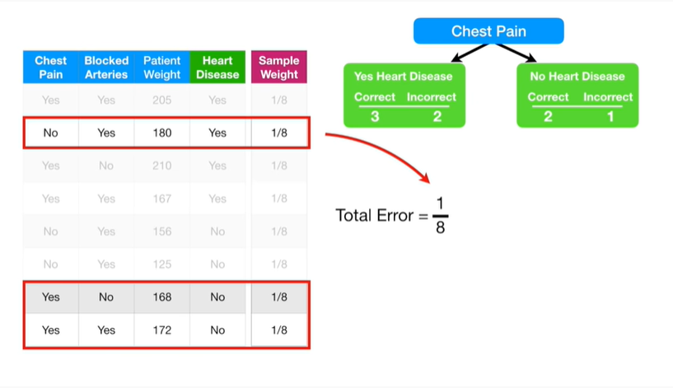

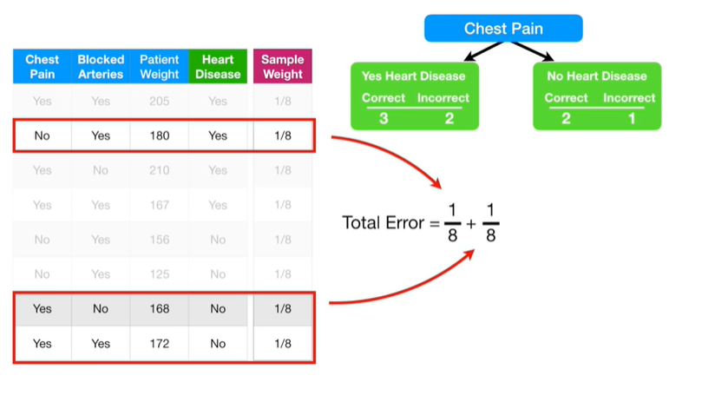

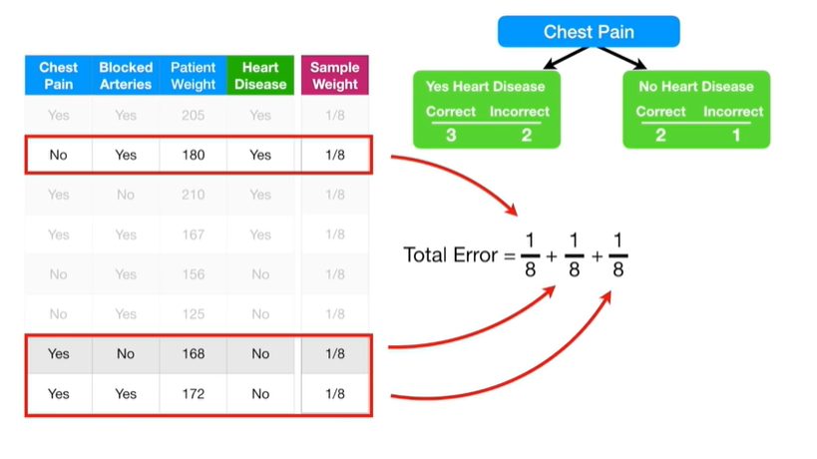

be do do booty.

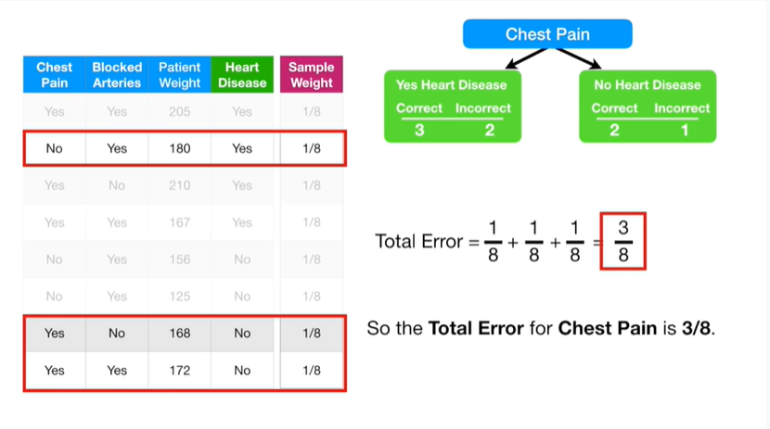

So the total error for chest pain is 3/8

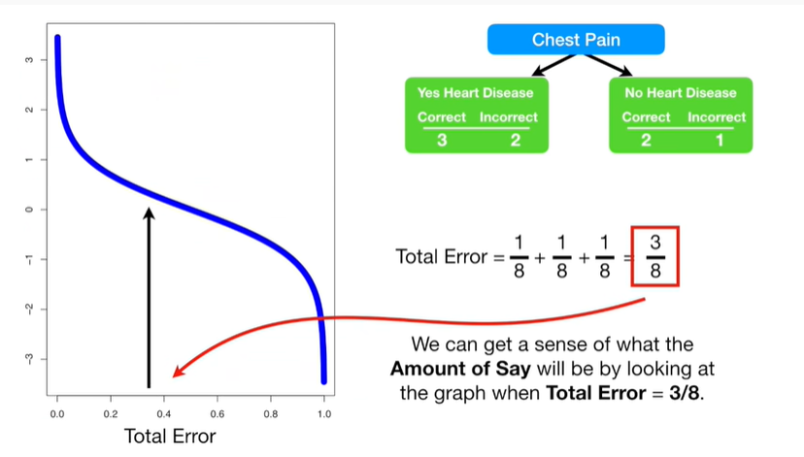

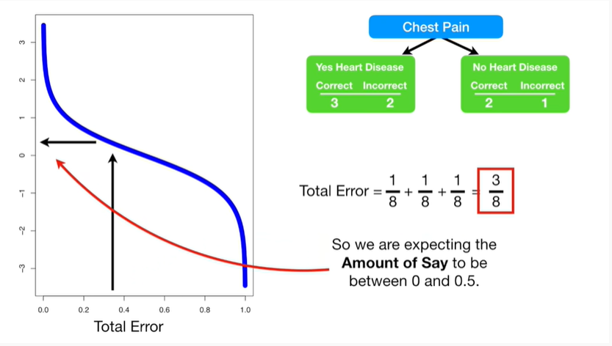

we can get a sense of what the amount of say will be by looking at the graph when total error equals 3/8.

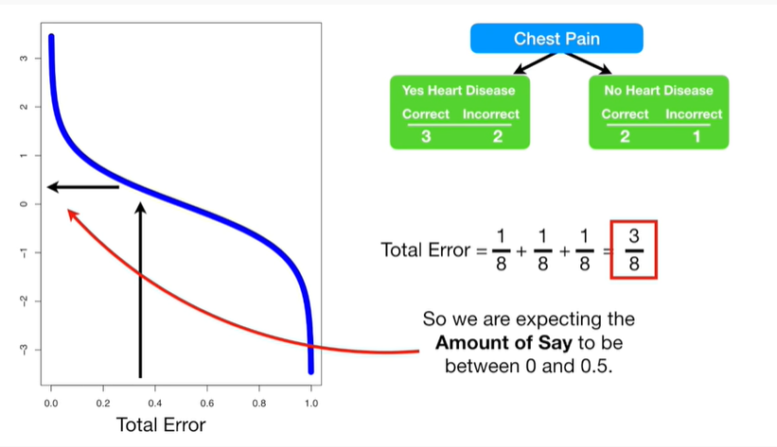

So we are expecting the amount of say to be between 0 and 0.5.

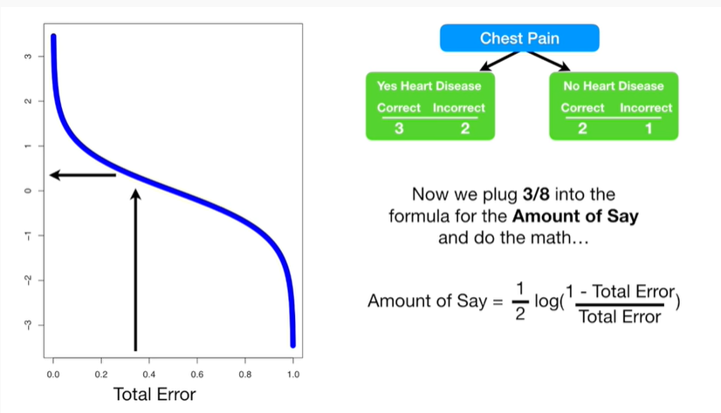

Now we plug 3/8 into the formula for the amount of say

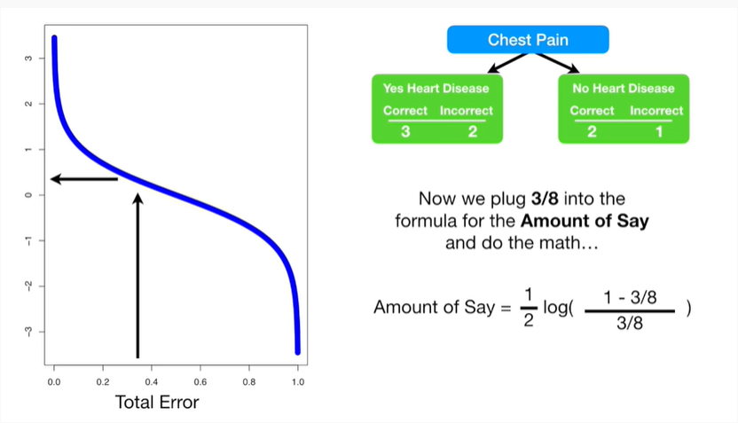

and do the math

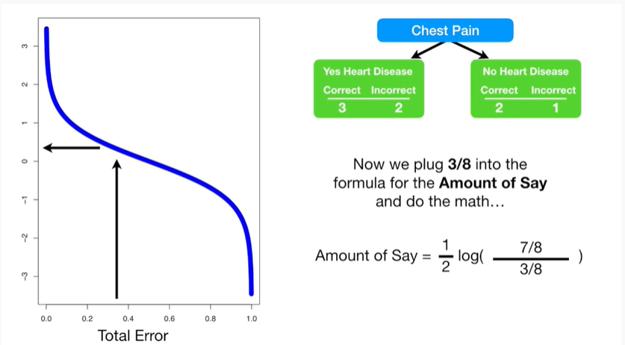

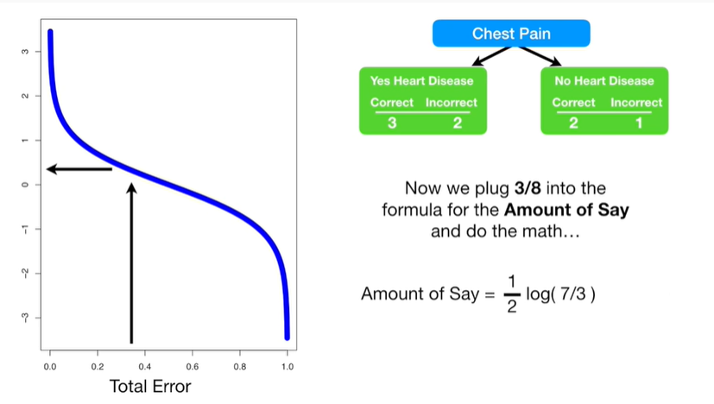

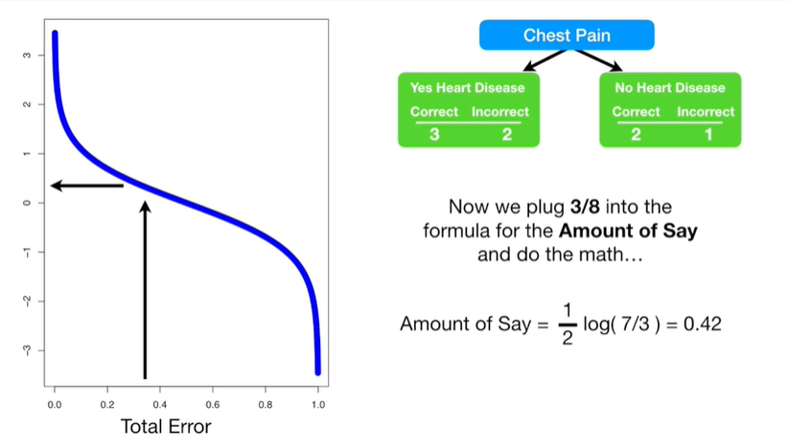

do t do pooty to do D pooh-coo pooh-coo

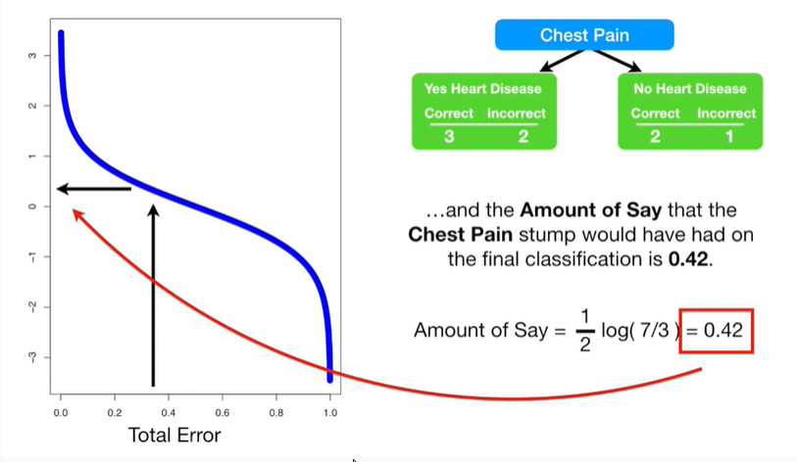

and the amount of say that the chest pain stump would have had on the final classification is 0.42.

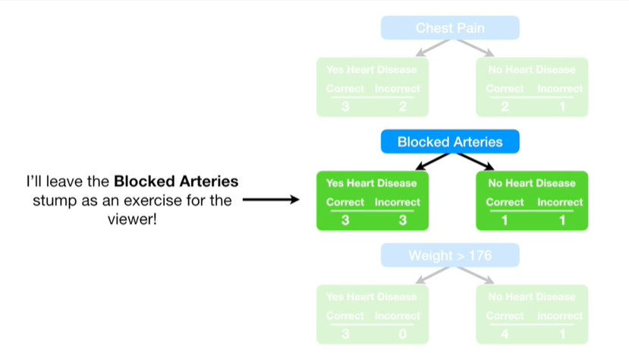

I'll leave the blocked artery stump as an exercise for the viewer.

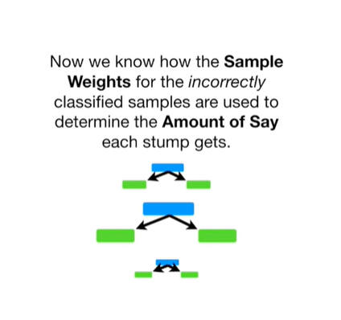

Now we know how the sample weights for the incorrectly classified samples are used to determine the amount of say each stump gets.

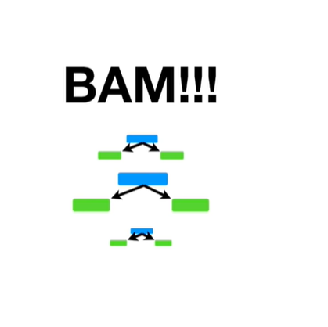

BAM !!!

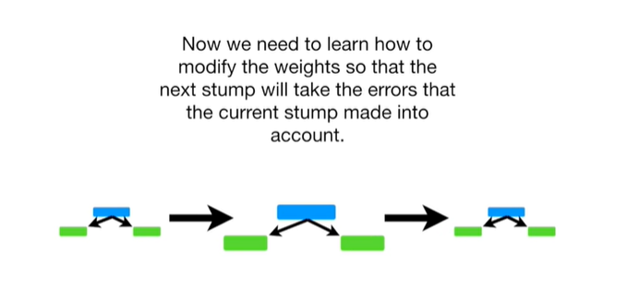

Now we need to learn how to modify the weights so that the next stump will take the errors that the current stump made into account.

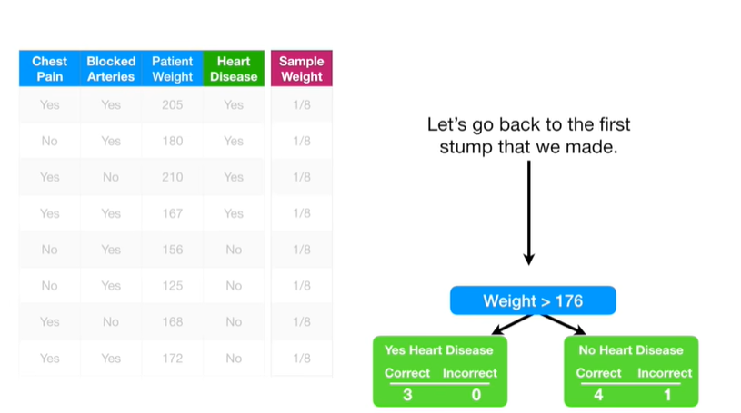

Let's go back to the first stump that we made.

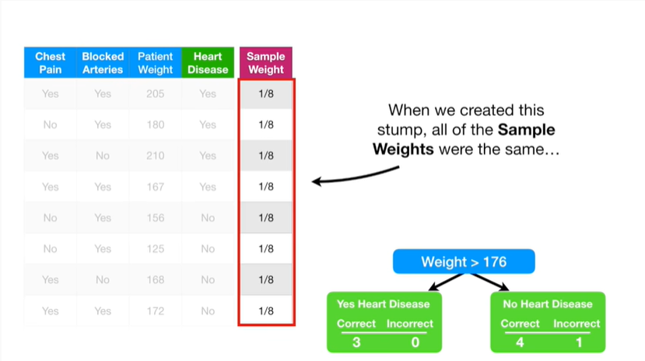

When we created this stump all of the sample weights were the same

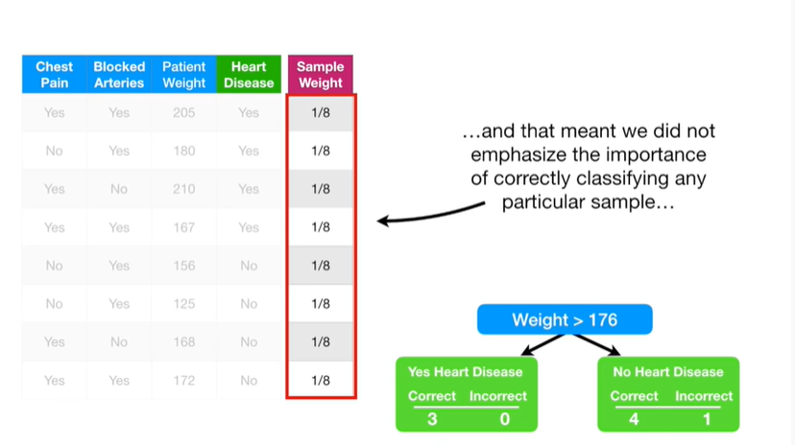

and that meant we did not emphasize the importance of correctly classifying any particular sample

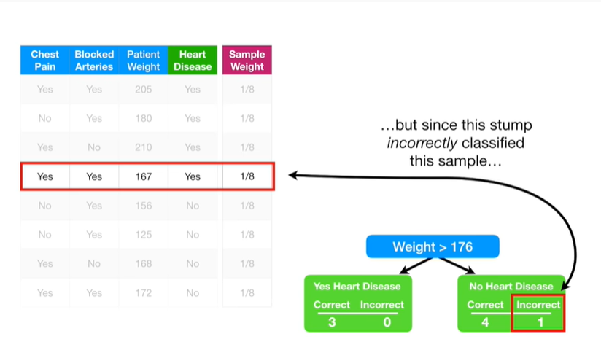

but since this stumped incorrectly classified this sample we will emphasize the need for the next stump to correctly classify it by increasing its sample weight

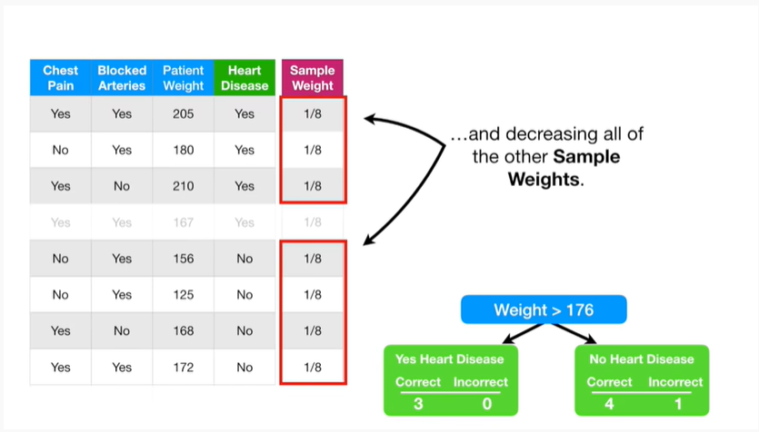

and decreasing all of the other sample weights.

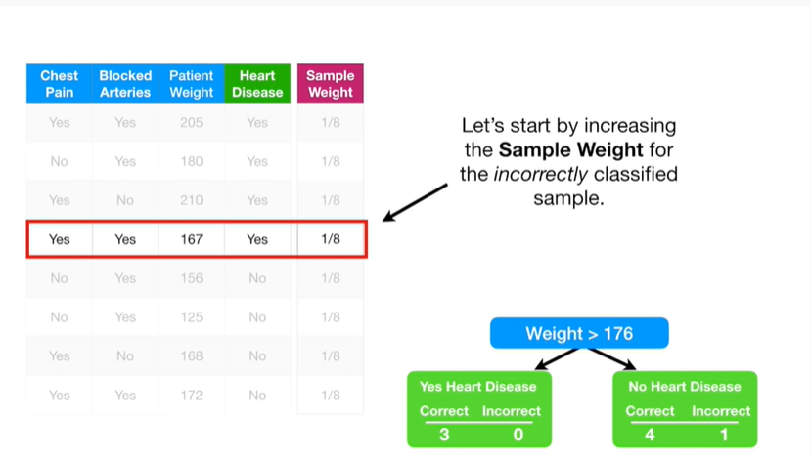

Let's start by increasing the sample wait for the incorrectly classified sample.

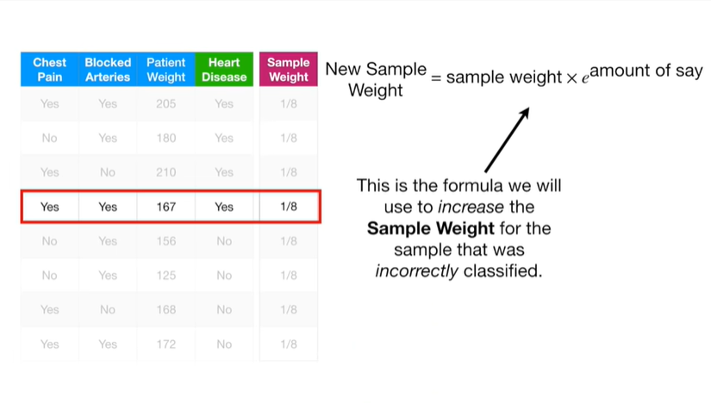

This is the formula we will use to increase the sample weight for the sample that was incorrectly classified.

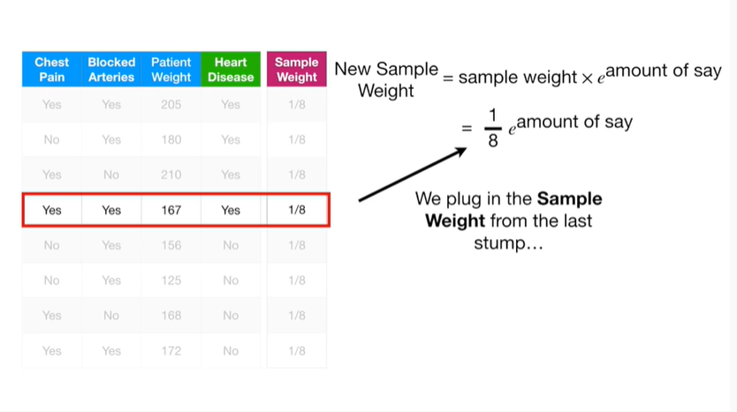

We plug in the sample weight from the last stump

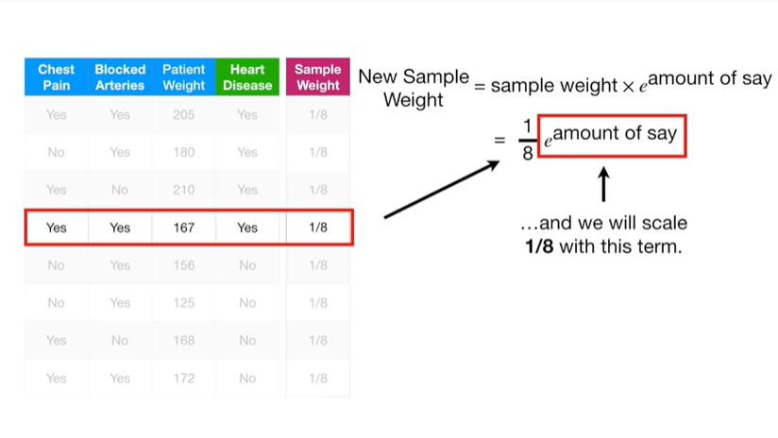

and we scale one eighth with this term.

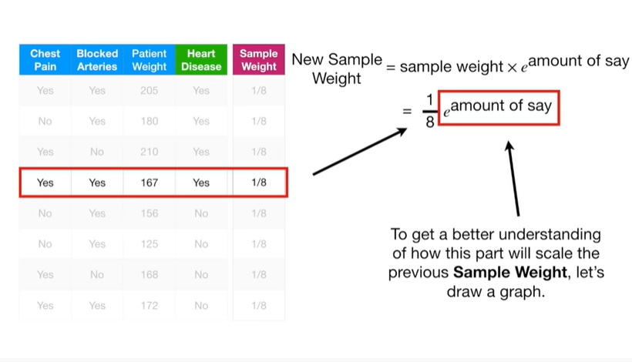

To get a better understanding of how this part will scale the previous sample weight,

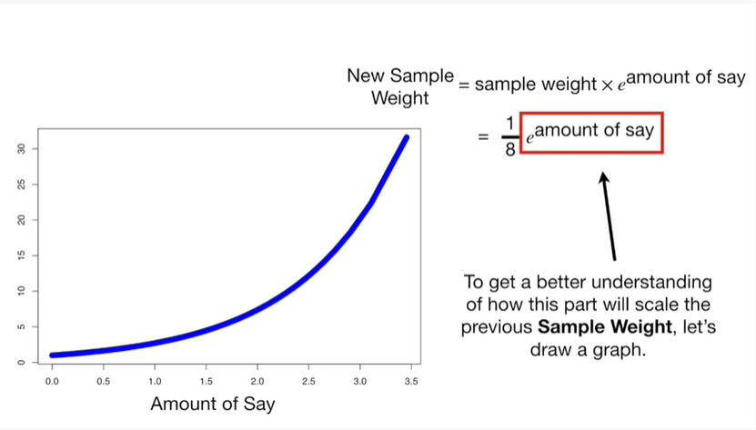

let's draw a graph.

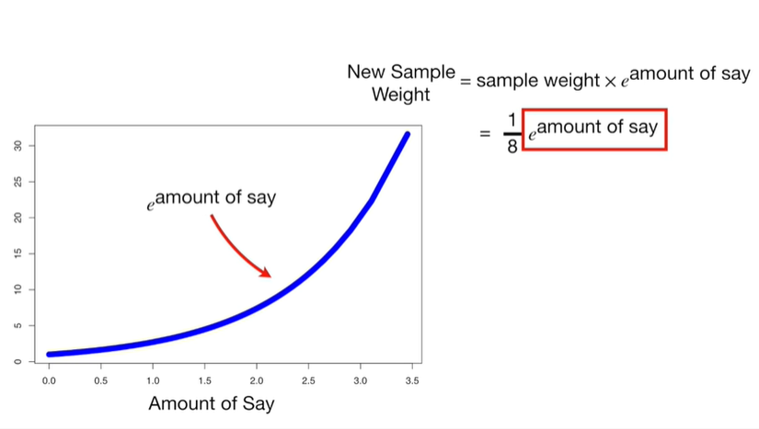

The blue line is equal to e raised to the amount of say.

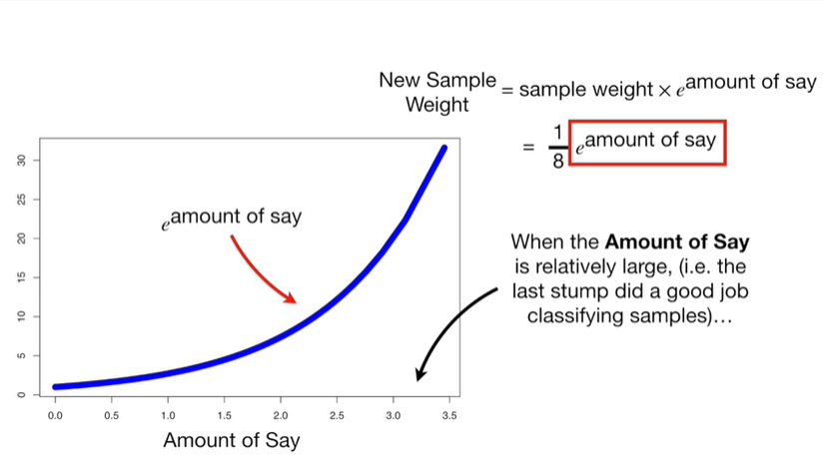

When the amount of say is relatively large ie the last stump did a good job classifying samples

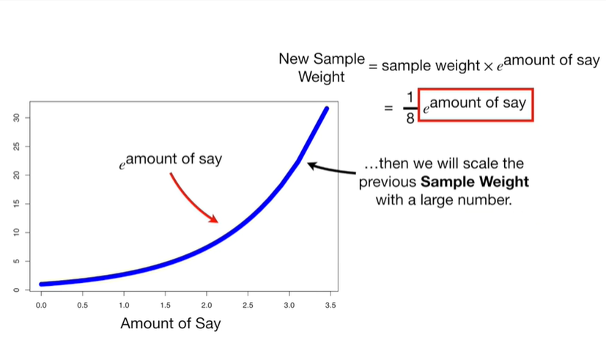

then we will scale the previous sample weight with a large number.

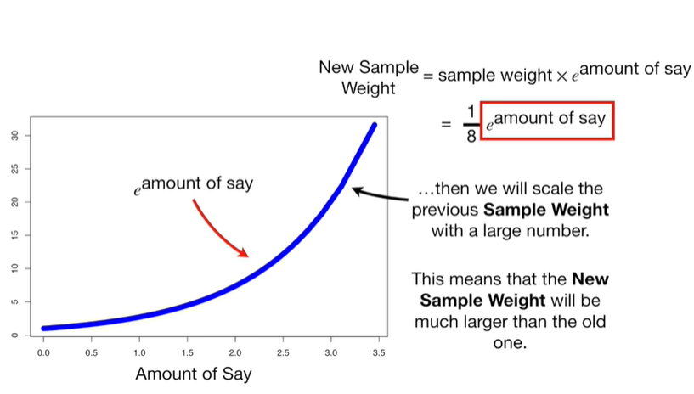

This means that the new sample weight will be much larger than the old one.

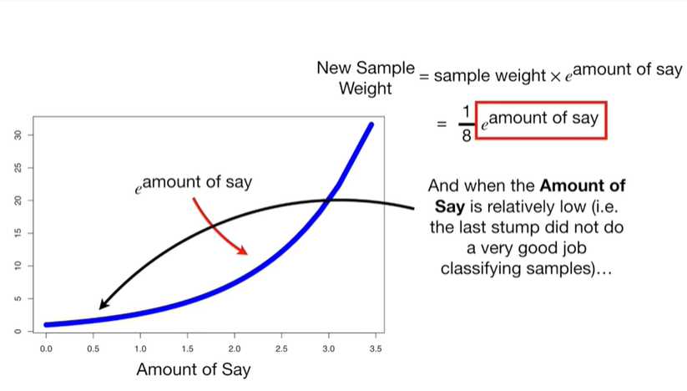

And when the amount of say is relatively low ie the last stump did not do a very good job classifying samples

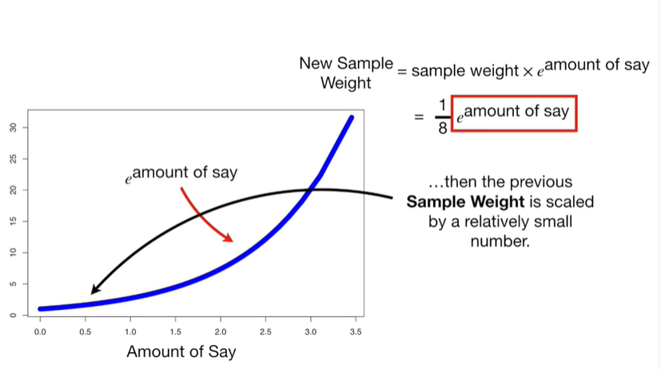

then the previous sample weight is scaled by a relatively small number.

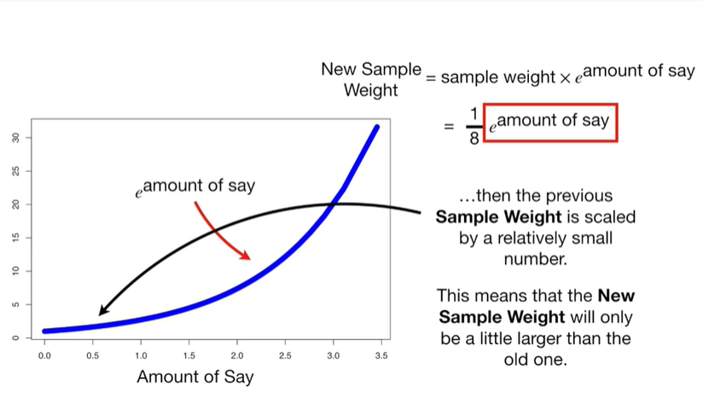

This means that the new sample weight will only be a little larger than the old one.

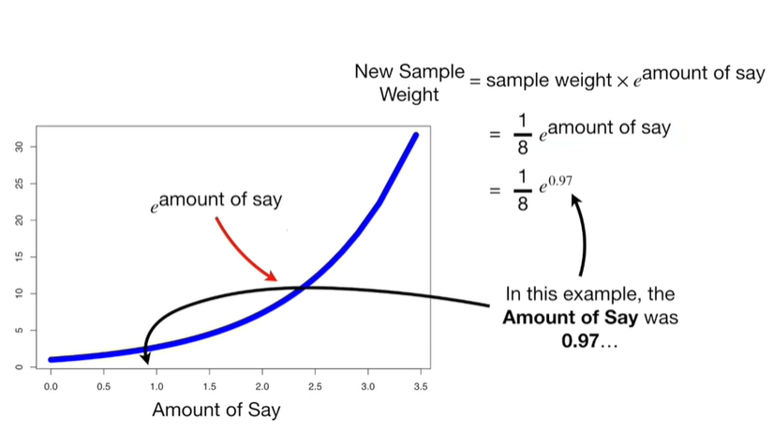

In this example, the amount of say was zero point nine seven

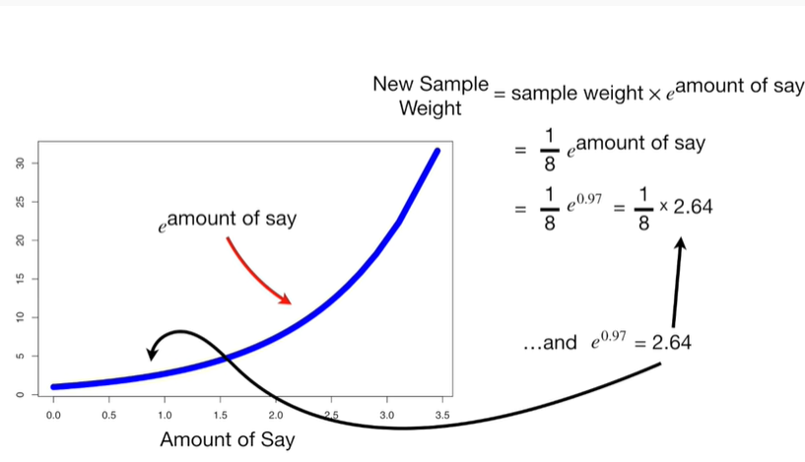

and e raised to the zero point nine seven equals two point six four

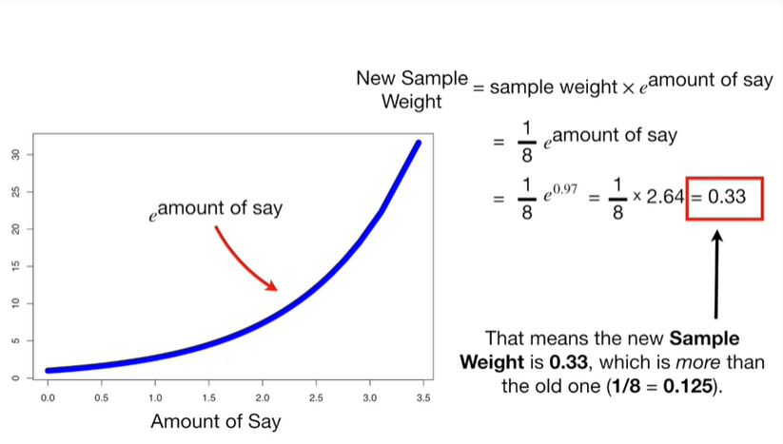

that means the new sample weight is zero point three three, which is more than the old one.

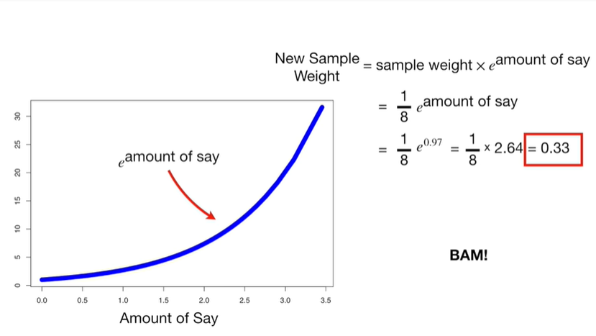

BAM !!!

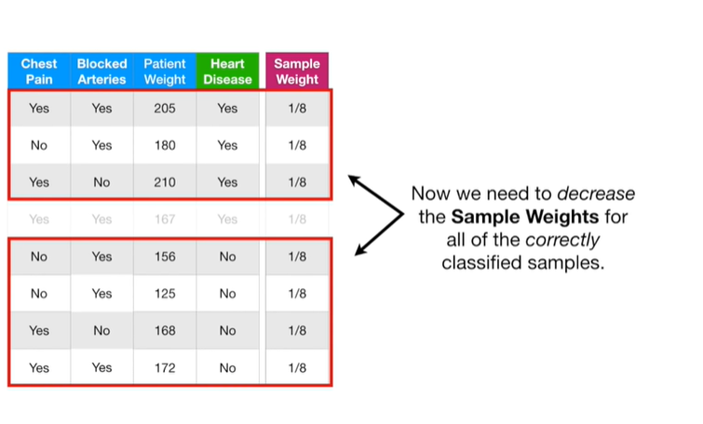

Now we need to decrease the sample weights for all of the correctly classified samples.

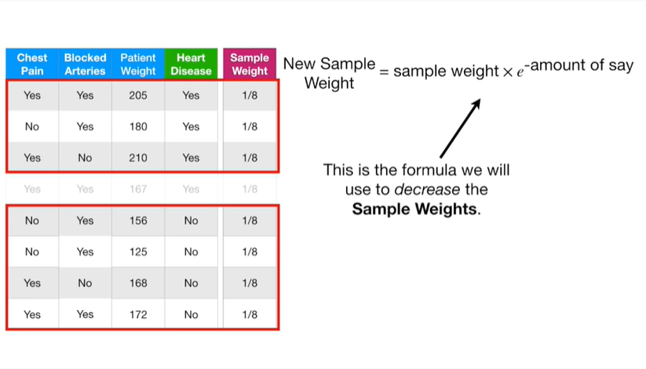

This is the formula we will use to decrease the sample weights.

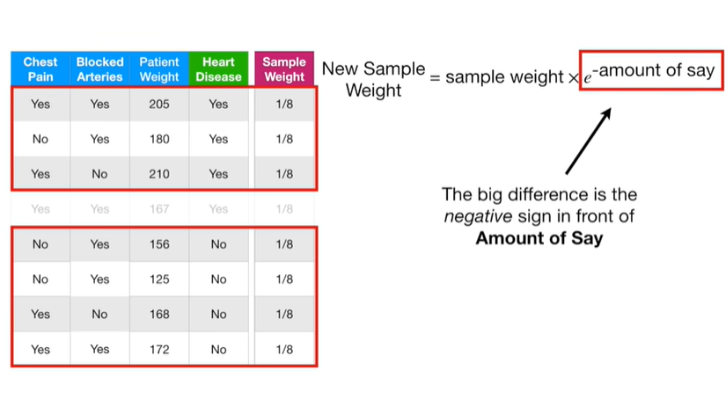

The big difference is the negative sign in front of amount of say.

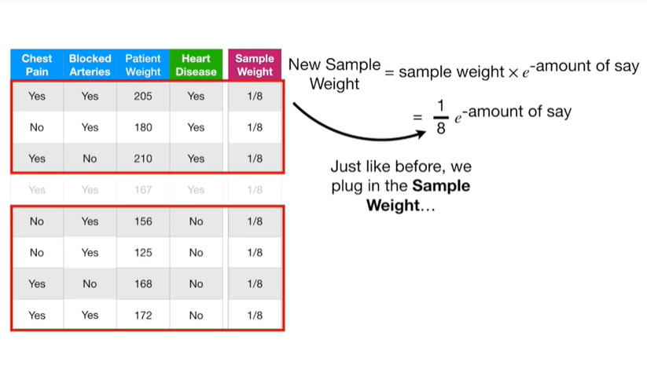

Just like before we plug in the sample weight

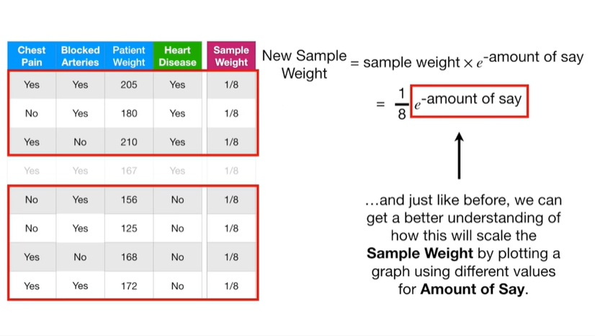

and just like before we can get a better understanding of how this will scale the sample weight

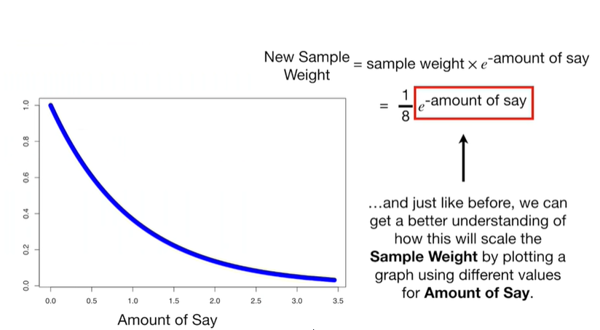

by plotting a graph using different values for amount of say.

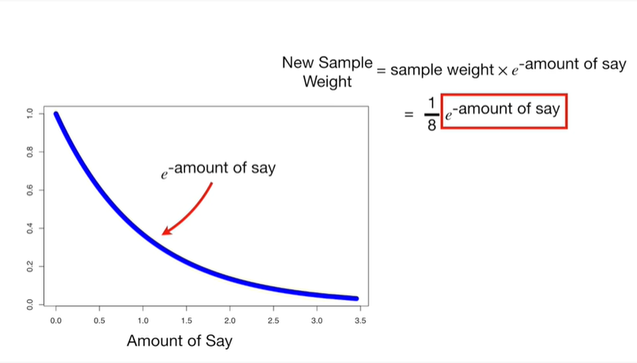

The blue line represents e raised to the negative amount of say.

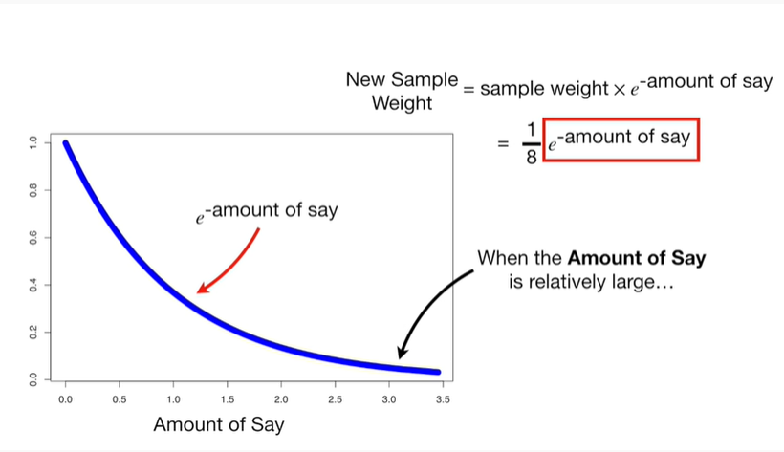

When the amount of se is relatively large

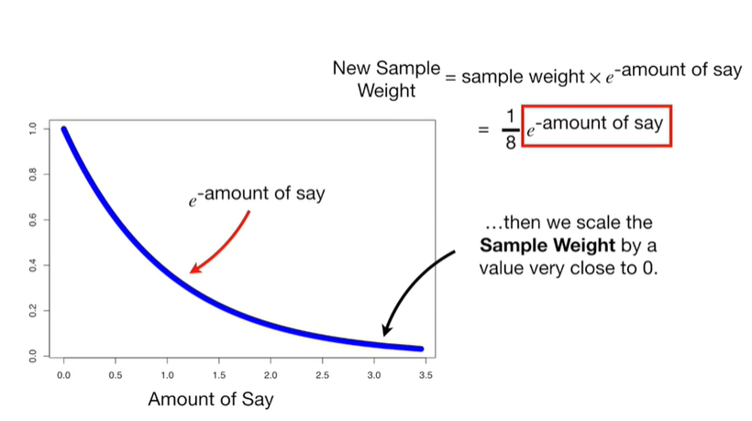

then we scale the sample weight by a value close to zero.

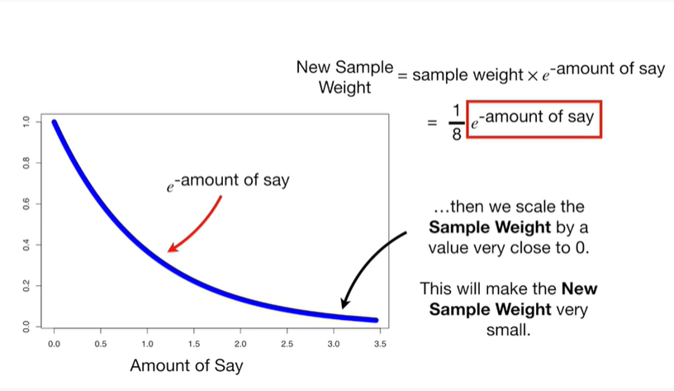

This will make the new sample weight very small.

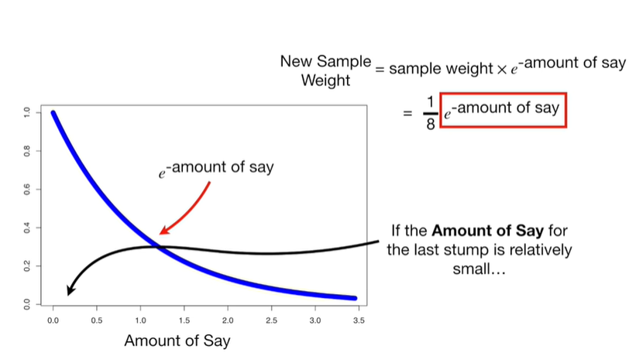

If the amount of say for the last stump is relatively small

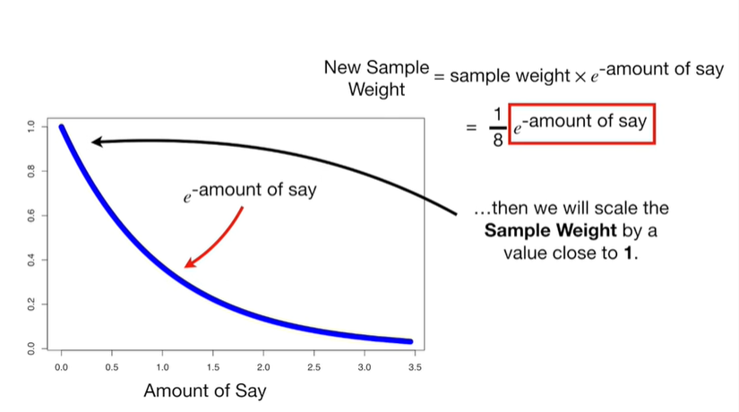

then we will scale the sample weight by a value close to 1.

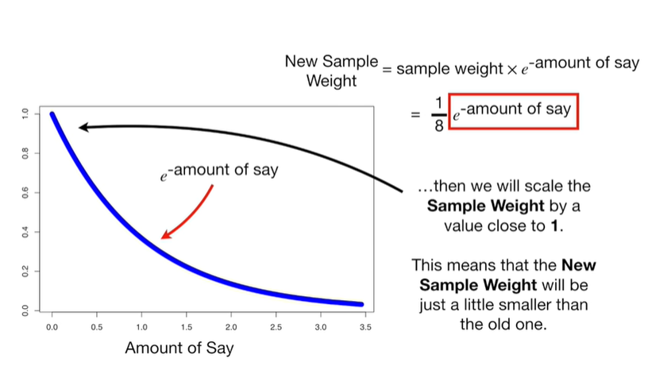

This means that the new sample weight will be just a little smaller than the old one.

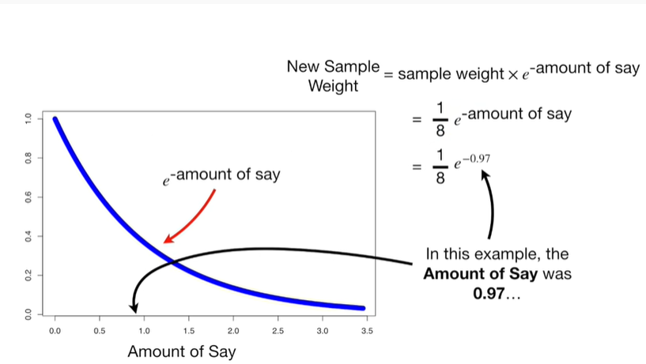

In this example the amount of say was 0.97

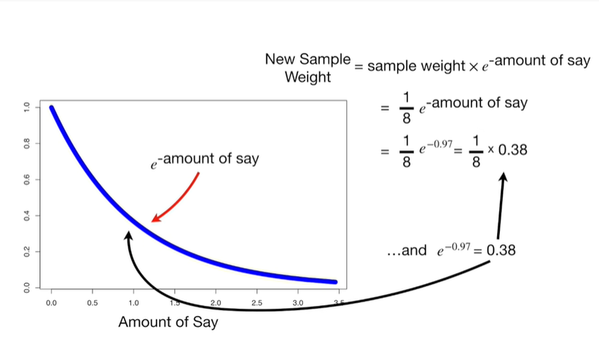

and e raised to the negative zero point nine seven equals zero point three eight.

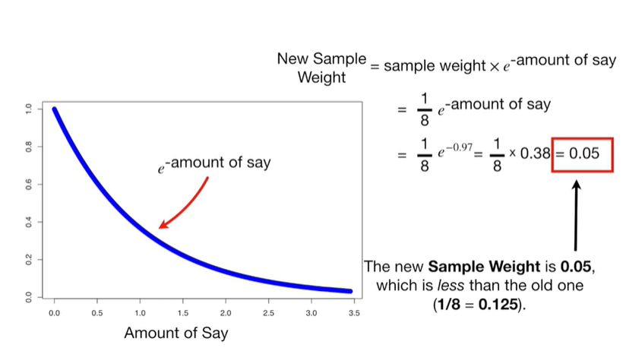

The new sample weight is zero point zero five, which is less than the old one.

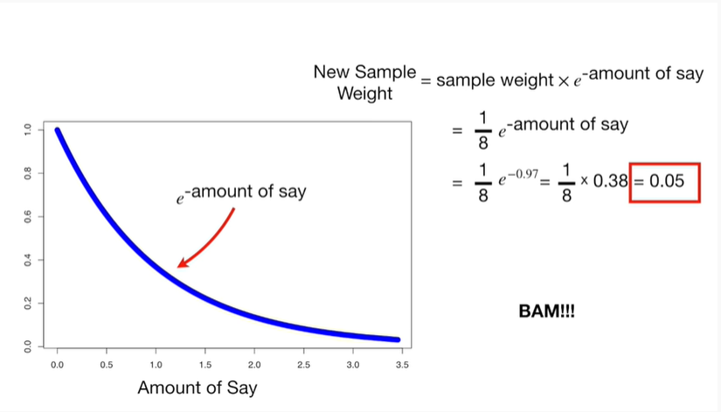

BAM !!!

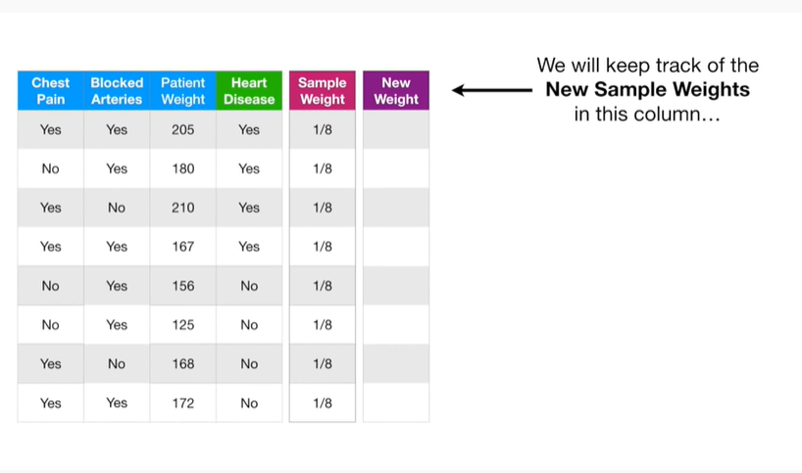

We will keep track of the new sample weights in this column.

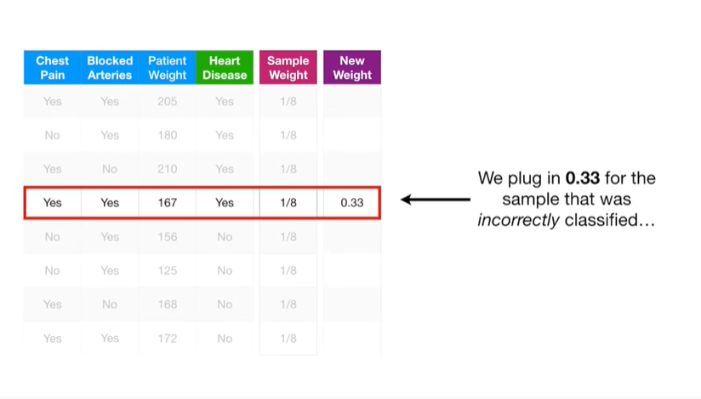

We plug in zero point three three for the sample that was incorrectly classified.

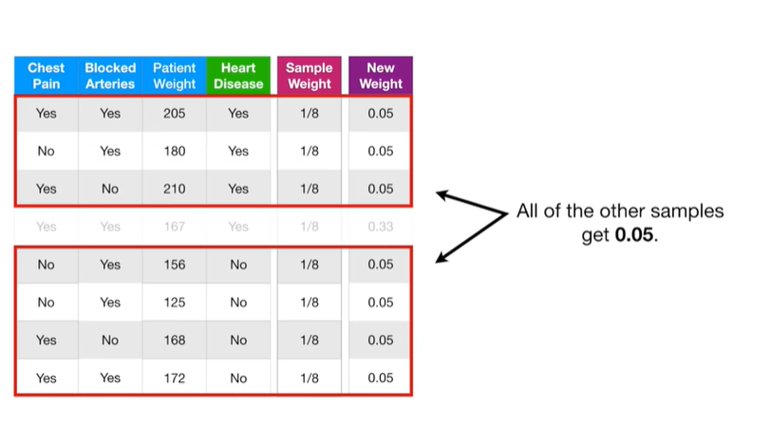

All of the other samples gets zero point zero five.

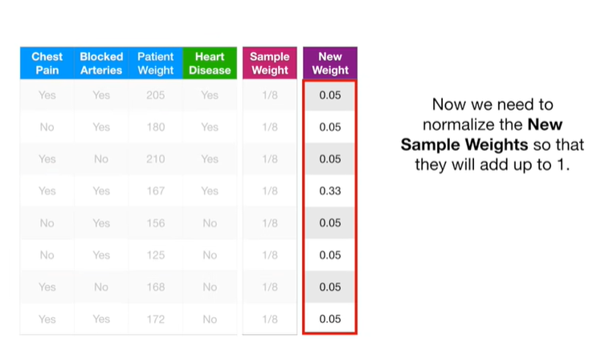

Now we need to normalize the new sample weights so that they will add up to one.

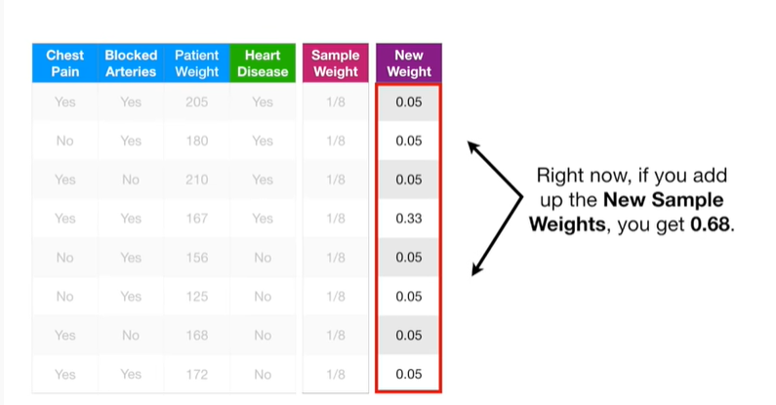

Right now if you add up the new sample weights, you get zero point six eight.

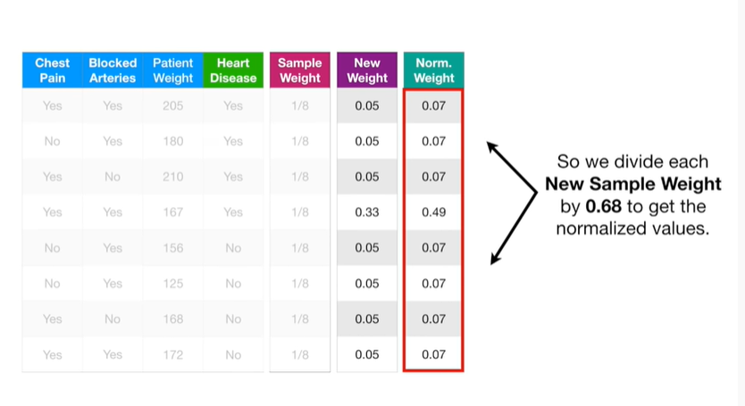

So we divide each new sample weight by 0.68 to get the normalized values.

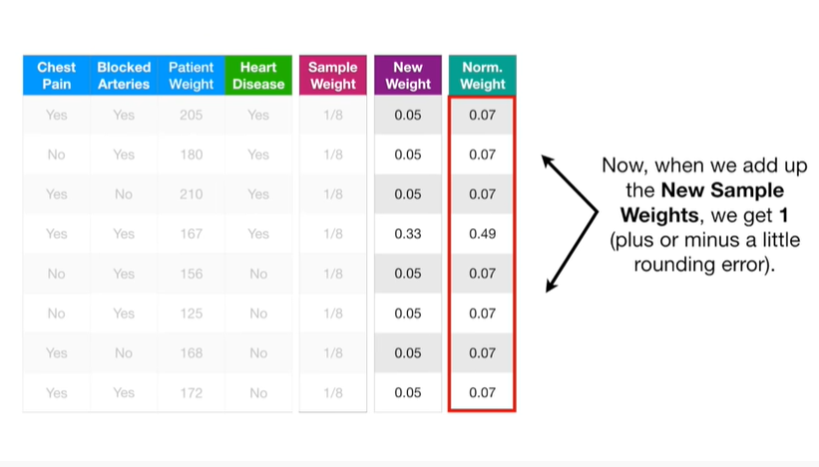

Now, when we add up the new sample weights, we get 1 plus or minus a little rounding error.

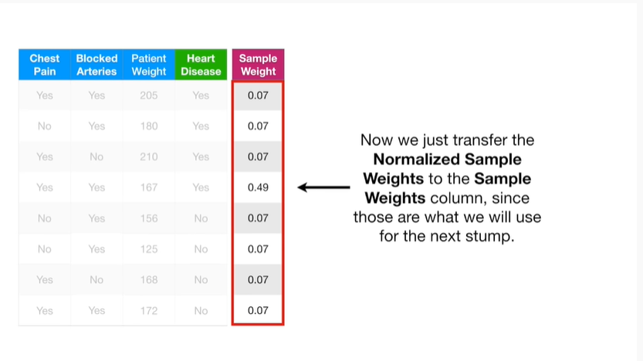

Now we just transfer the normalized sample weights to the sample weights column since those are what we will use for the next stomp.

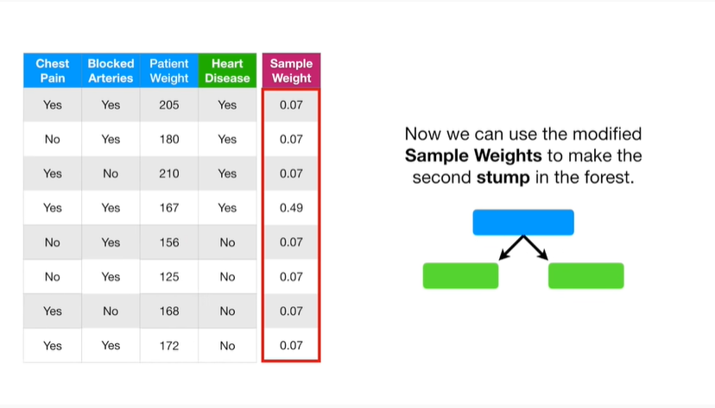

Now we can use the modified sample weights to make the second stump in the forest.

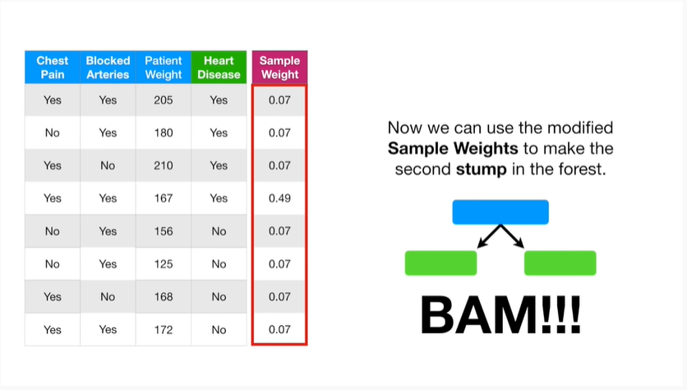

BAM !!!

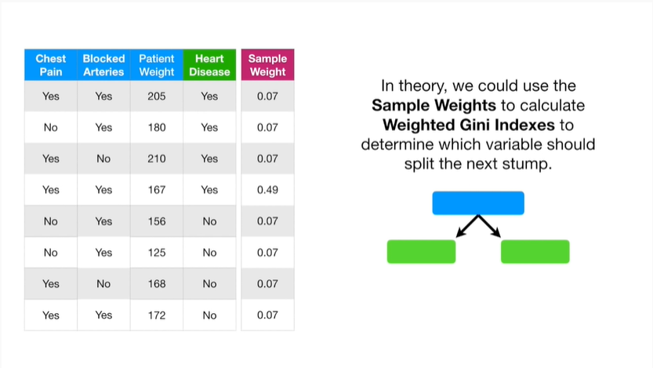

In theory, we could use the sample weights to calculate weighted genie indexes to determine which variable should split the next stump.

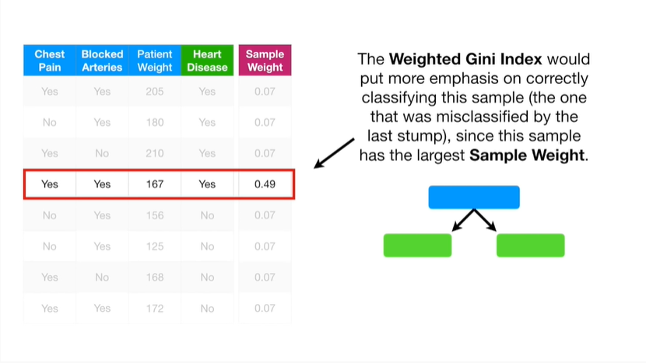

The weighted genie index would put more emphasis on correctly classifying this sample (the one that was miss classified by the last stump) since this sample has the largest sample weight.

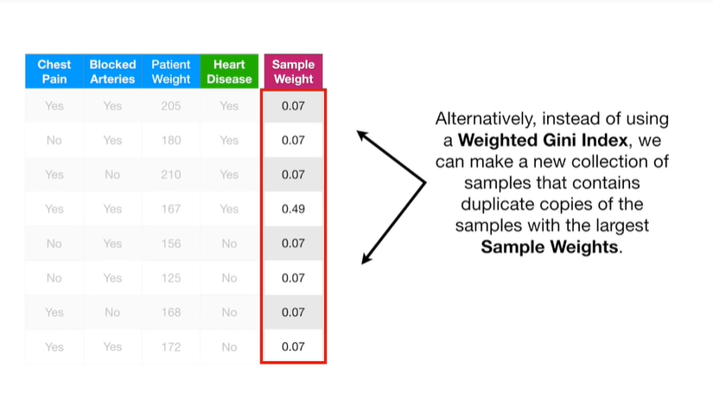

Alternatively instead of using a weighted Gini index, we can make a new collection of samples that contains duplicate copies of the samples with the largest sample weights.

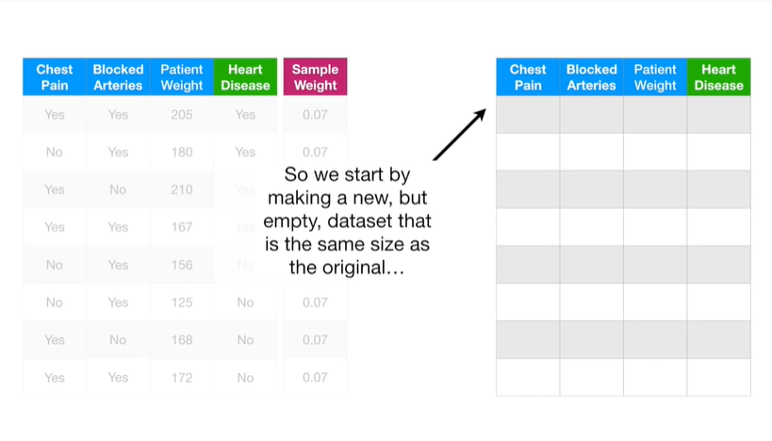

So we start by making a new but empty data set that is the same size as the original

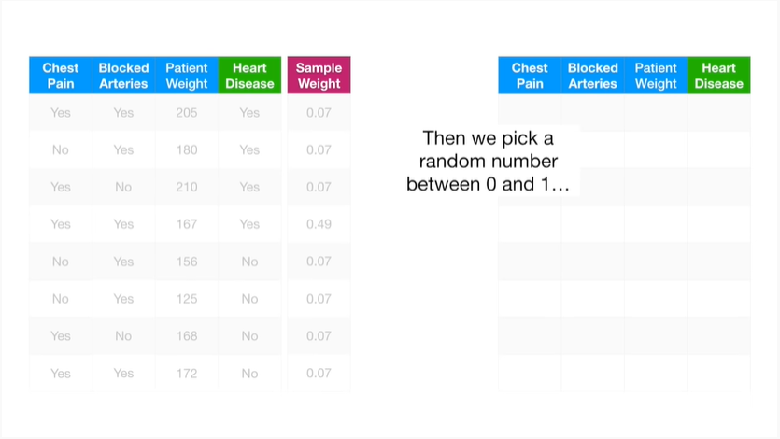

then we pick a random number between 0 and 1

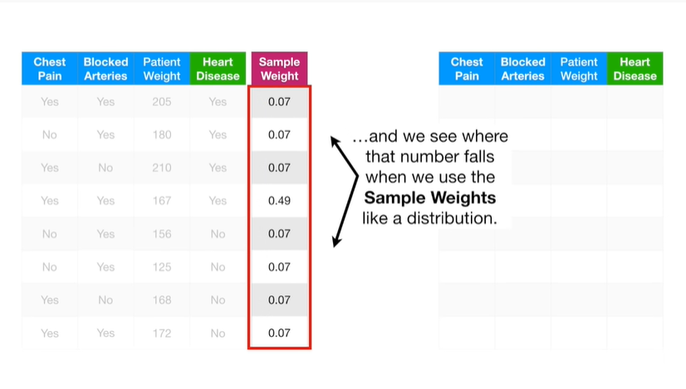

and we see where that number falls when you use the sample weights like a distribution.

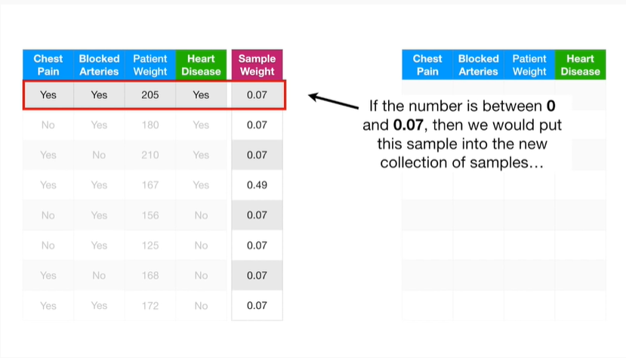

If the number is between 0 and 0.7 then we would put this sample into the new collection of samples

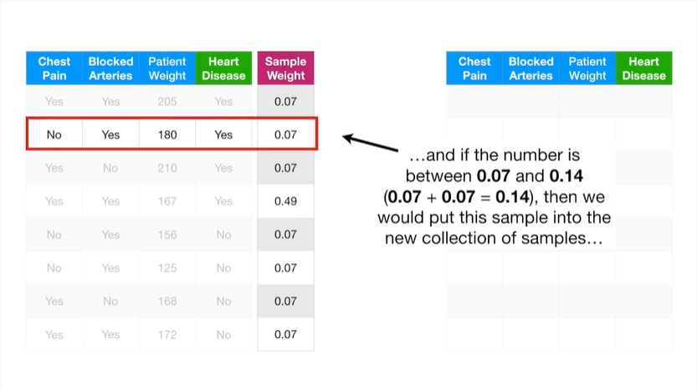

and if the number is between 0.7 and 0.14 then we would put this sample into the new collection of samples

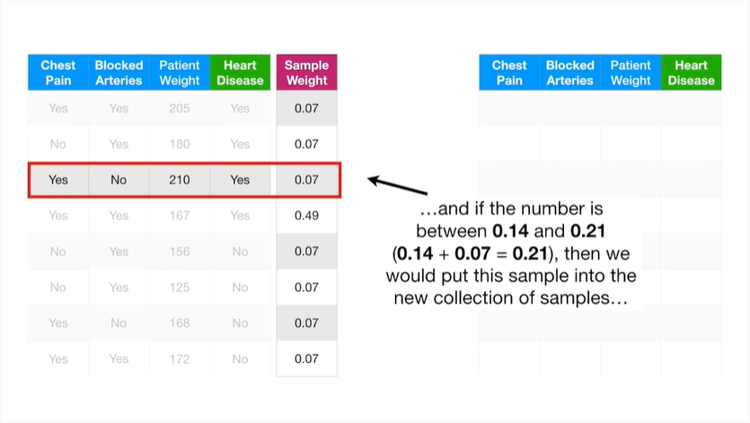

and if the number is between 0.14 and 0.2 1 then we would put this sample into the new collection of samples

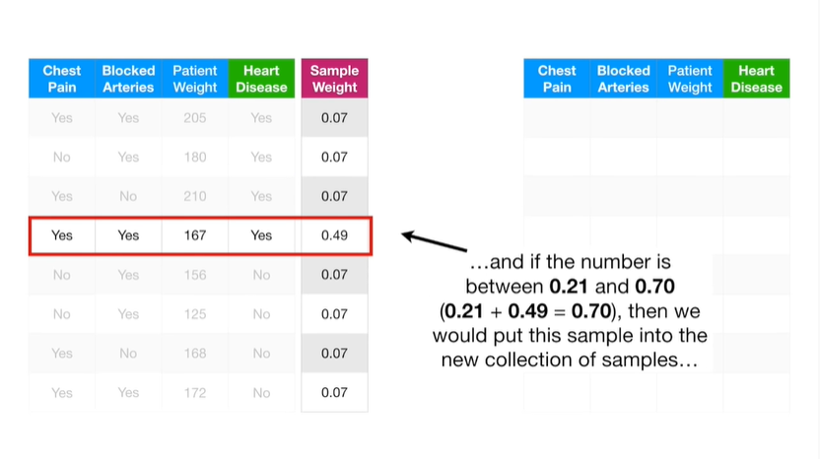

and if the number is between zero point two one and zero point seven zero then we would put this sample into the new collection of samples

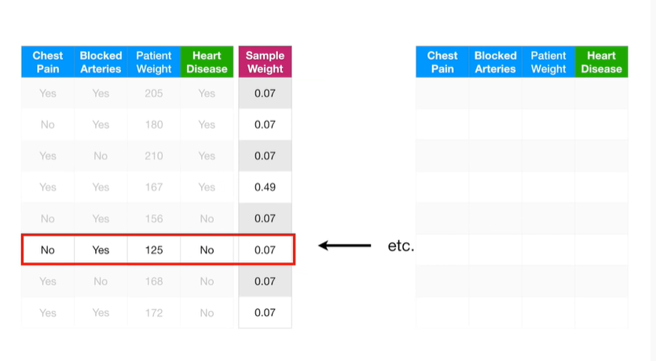

Etc etc…

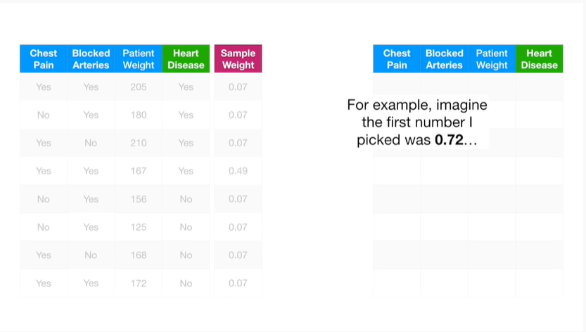

For example imagine the first number I picked was 0.72

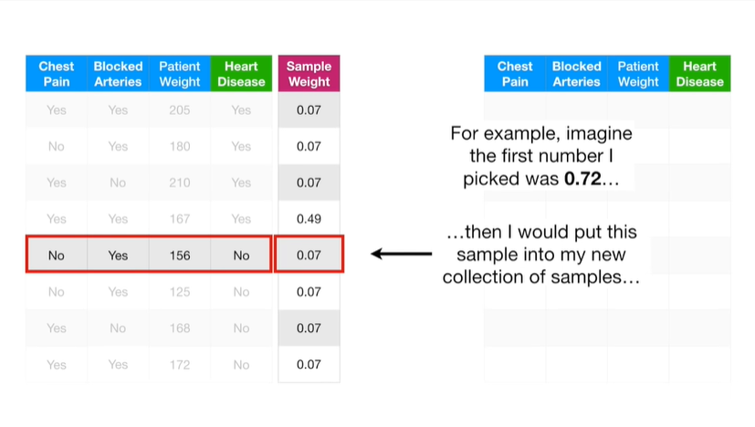

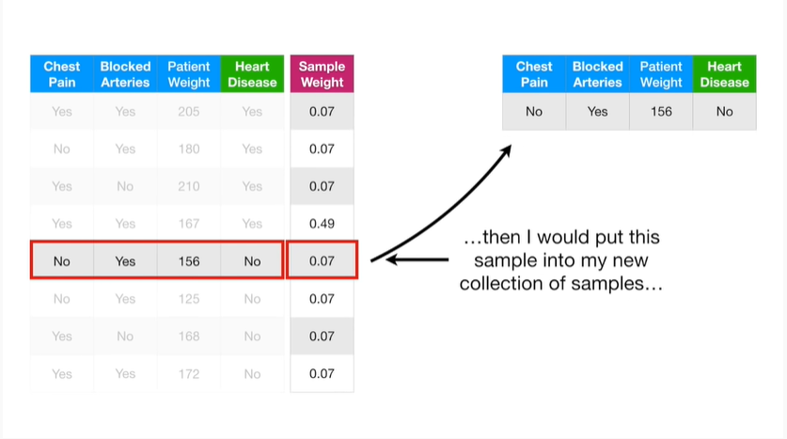

then I would put this sample into my new collection of samples.

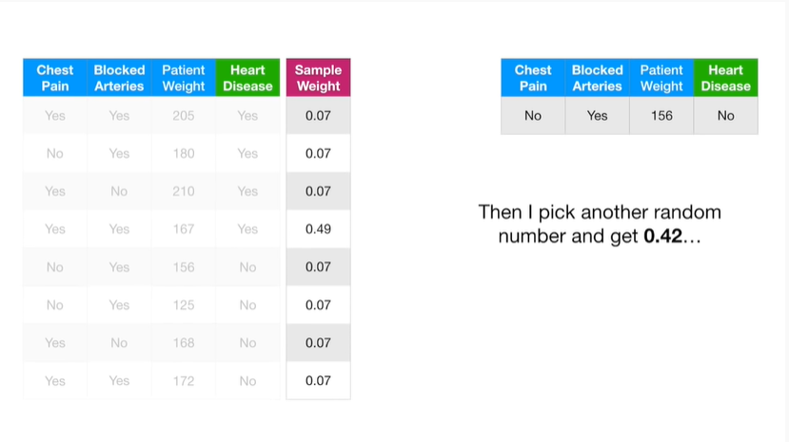

Then I pick another random number and get 0.42

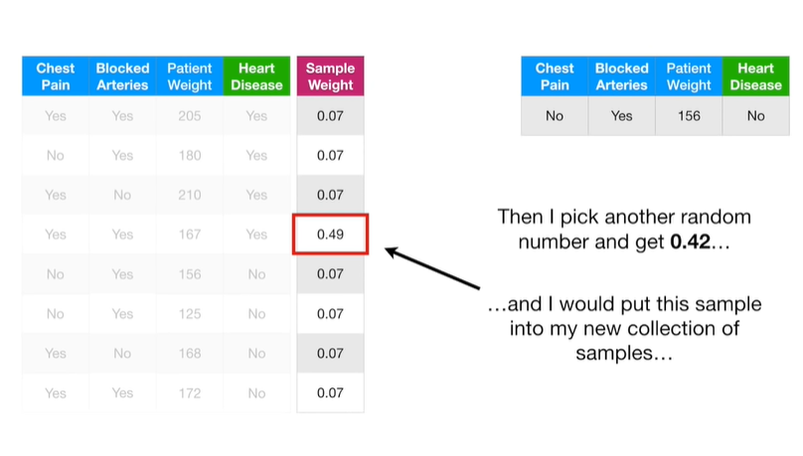

and I would put this sample into my new collection of samples

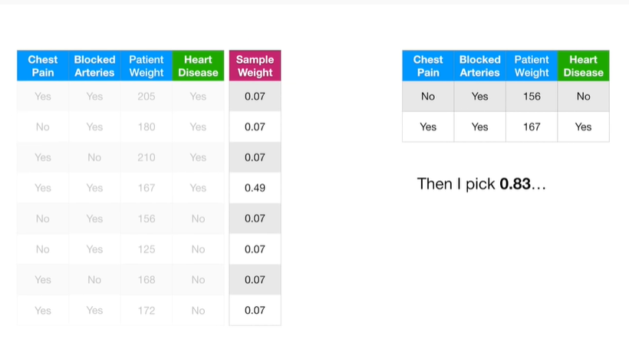

then I pick 0.83

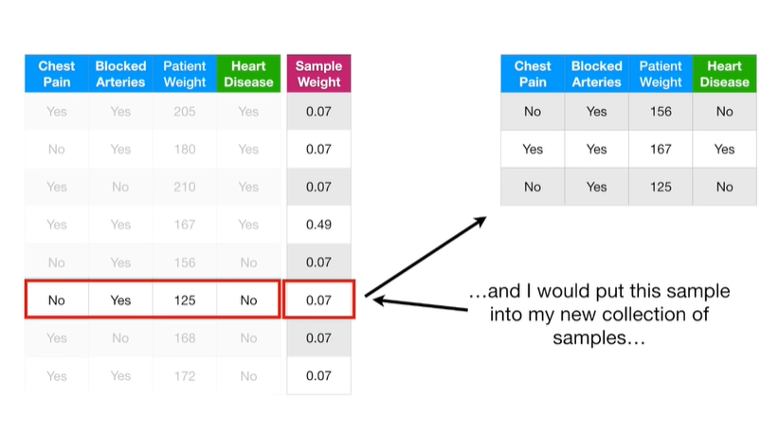

and I would put this sample into my new collection of samples

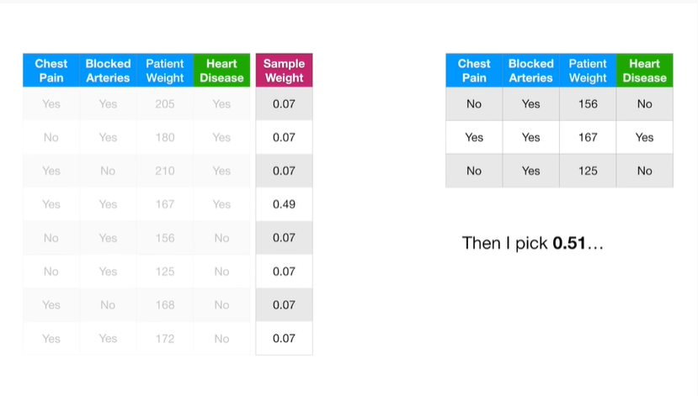

then I pick 0.51

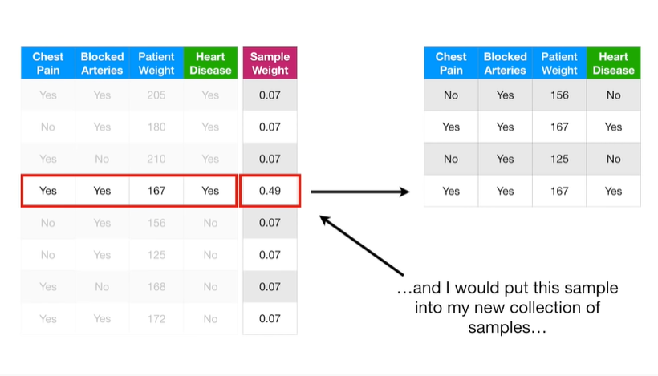

and I would put this sample into my new collection of samples.

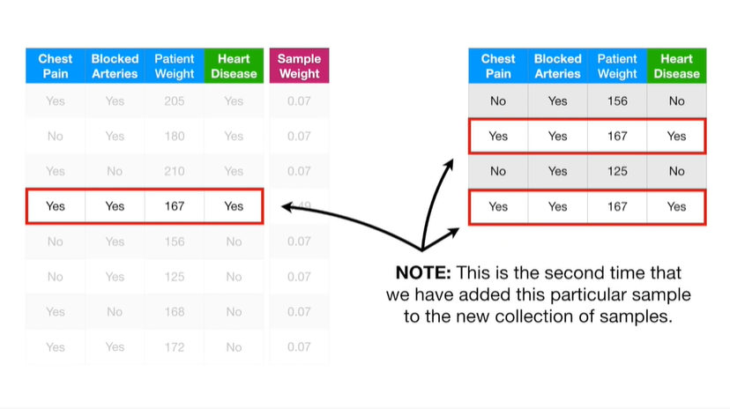

Note : this is the second time we have added this particular sample to the new collection of samples.

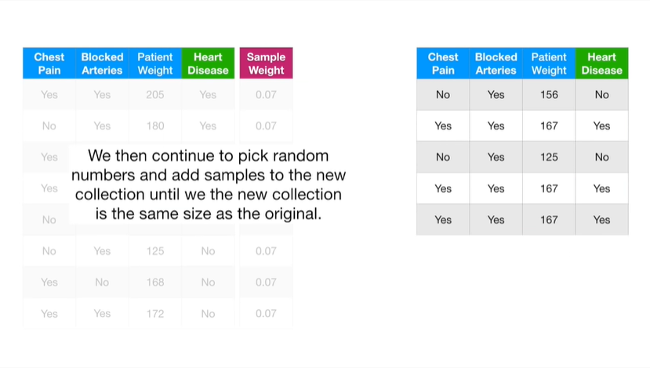

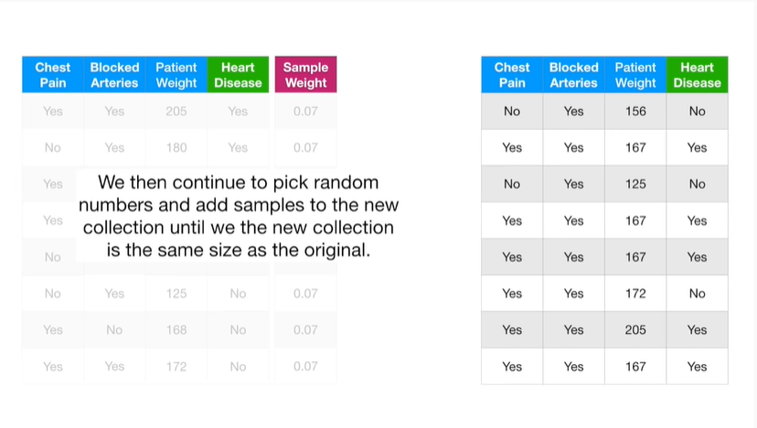

We then continue to pick random numbers and add samples to the new collection until the new collection is the same size as the original.

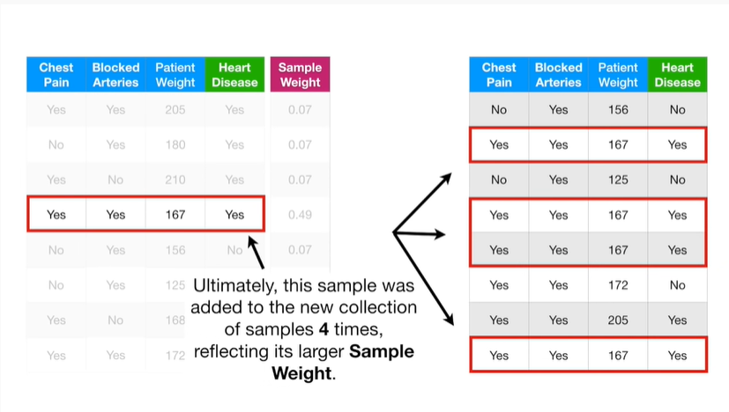

Ultimately this sample was added to the new collection of samples four times reflecting its larger sample weight.

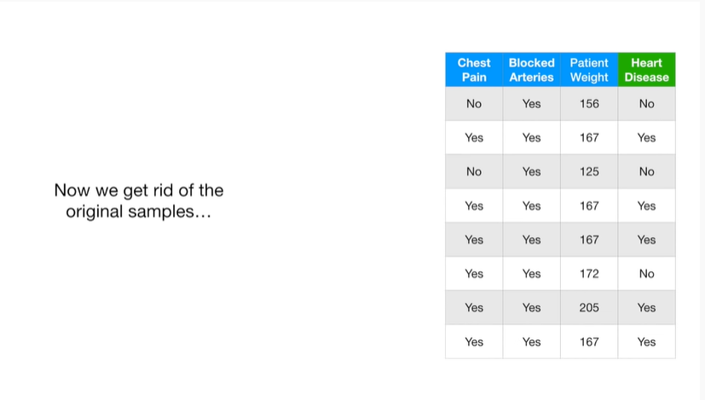

Now we get rid of the original samples

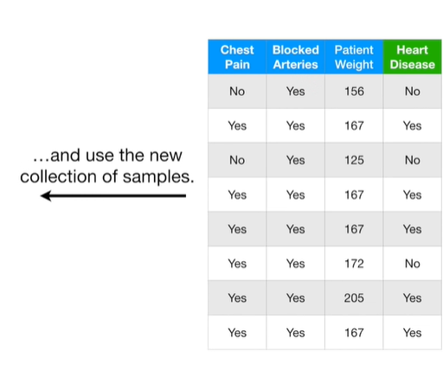

and use the new collection of samples.

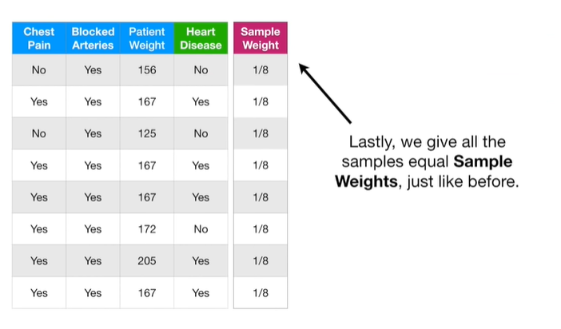

Lastly, we give all of the samples equal sample weights, just like before.

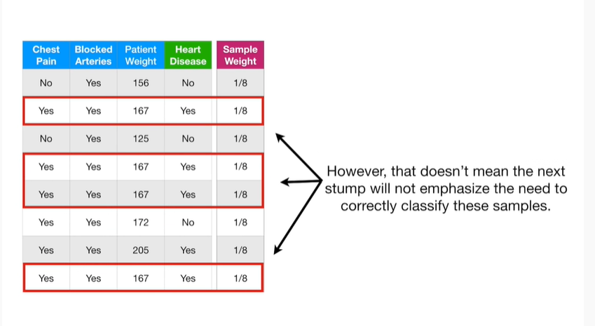

However, that doesn't mean the next stump will not emphasize the need to correctly classify these samples.

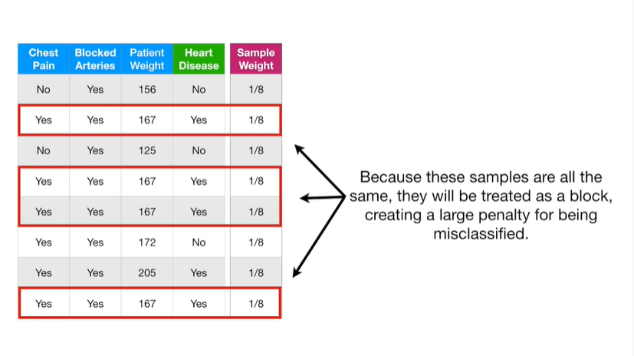

Because these samples are all the same they will be treated as a block, creating a large penalty for being misclassified.

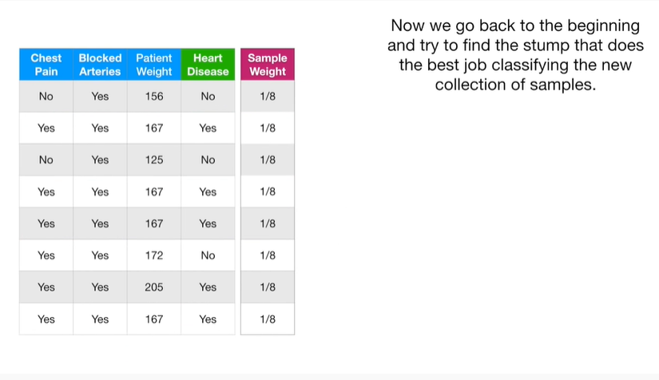

Now we go back to the beginning and try to find the stump

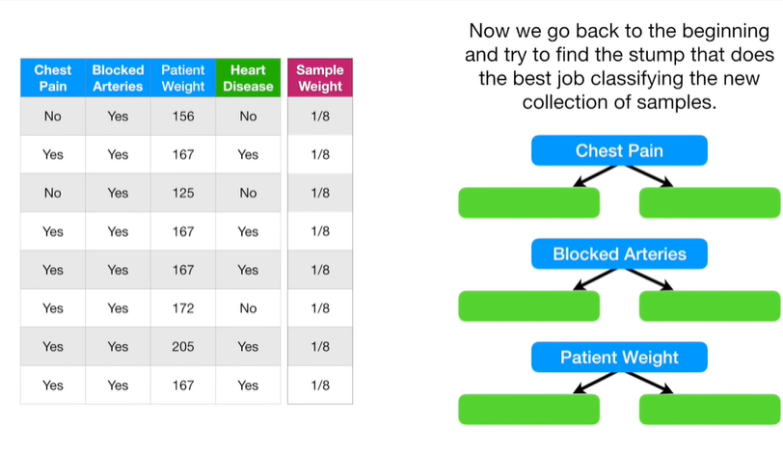

that does the best job classifying the new collection of samples.

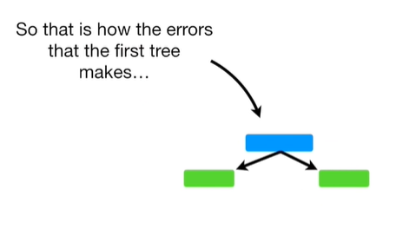

So that is how the errors that the first tree makes

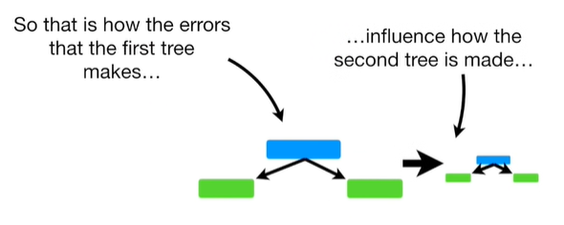

influence how the second tree is made

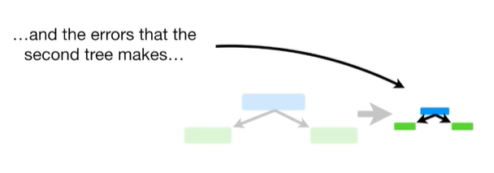

and how the errors that the second tree makes

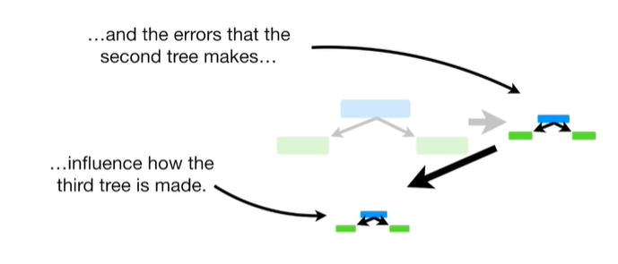

influence how the third tree is made.

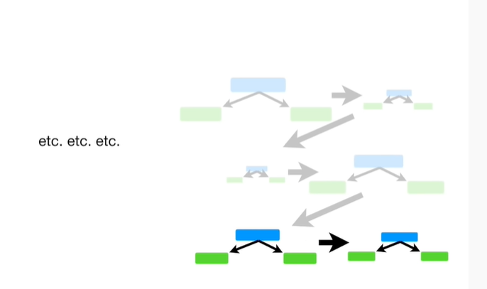

Etc etc etc…

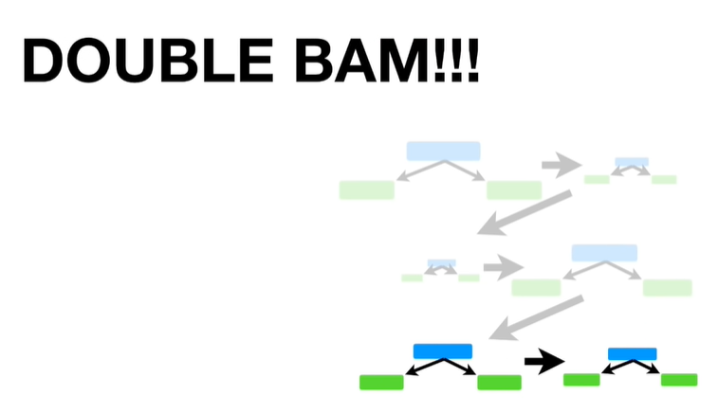

Double bam !!!

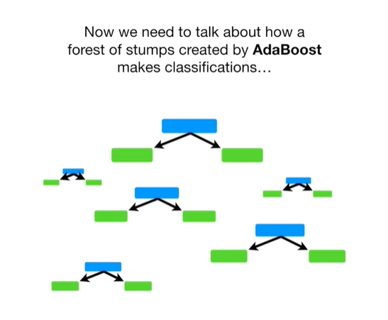

Now we need to talk about how a forest of stumps created by adaboost makes classifications.

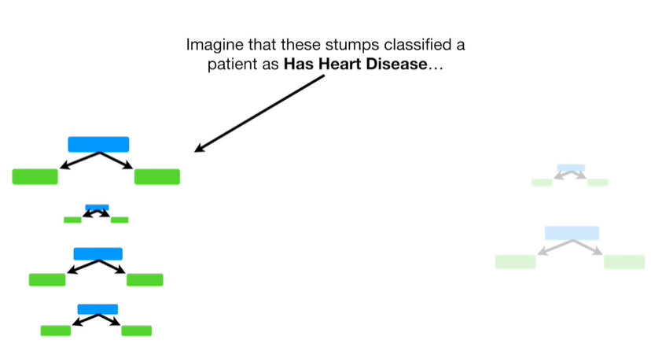

Imagine that these stumps classified a patient as has heart disease

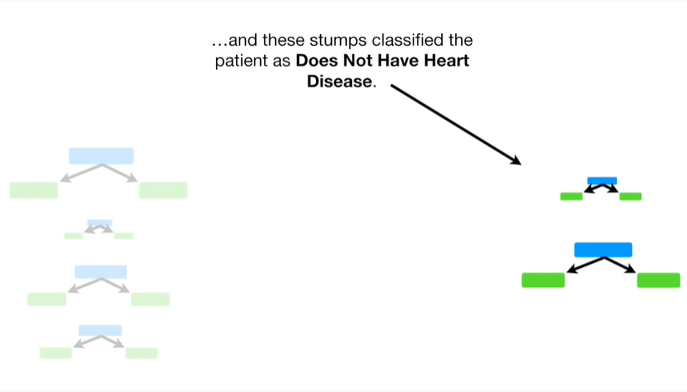

and these stumps classified the patient as does not have heart disease.

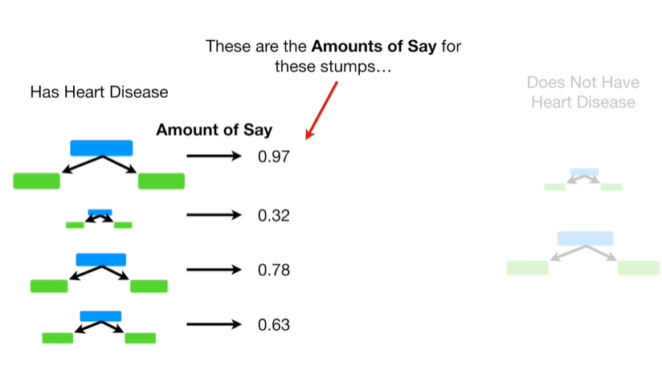

These are the amounts of say for these stumps

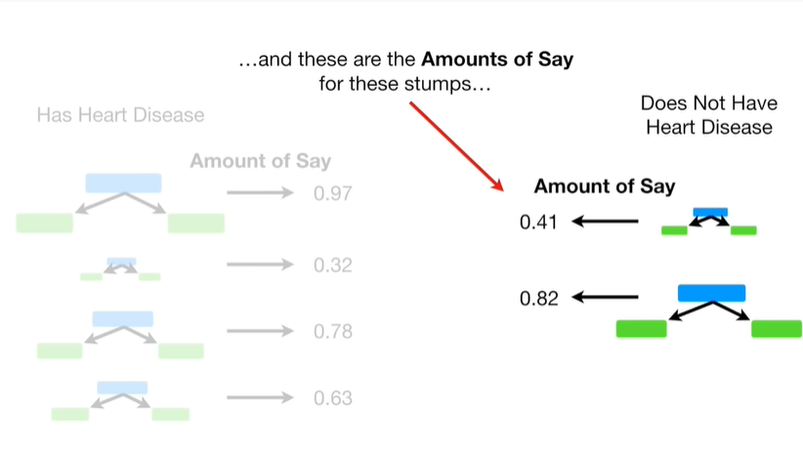

and these are the amounts of say for these stumps.

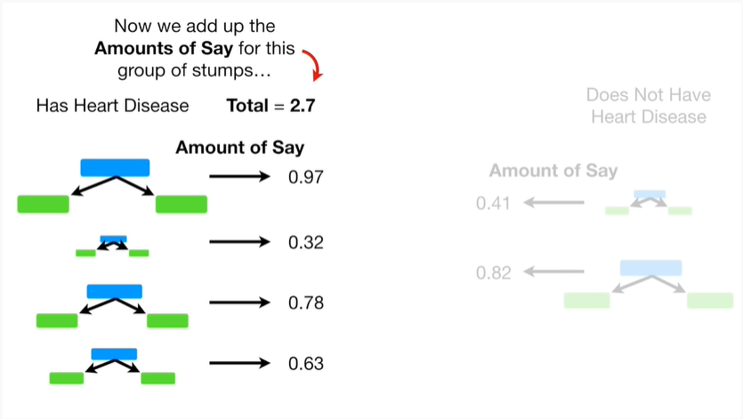

Now we add up the amounts of say for this group of stumps

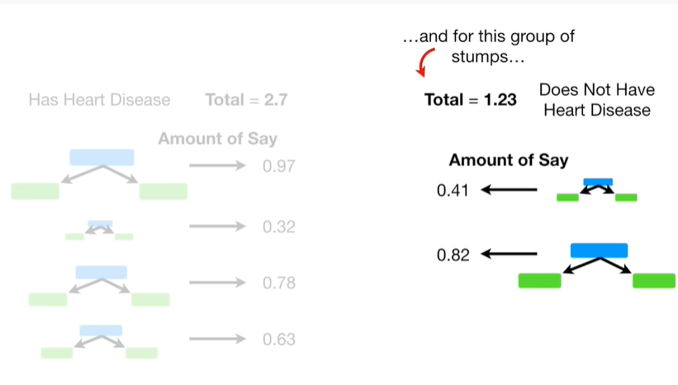

and for this group of stumps.

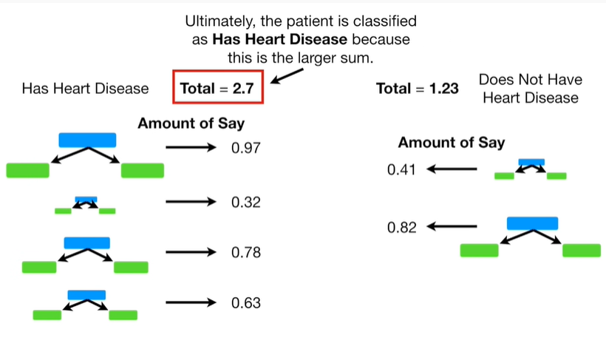

Ultimately the patient is classified as has heart disease because this is the larger sum.

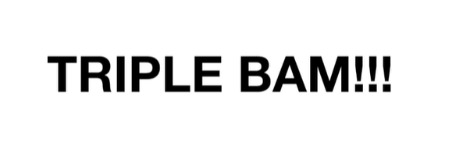

Triple bam !!!

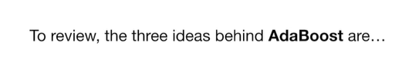

To review the three ideas behind adaboost are :

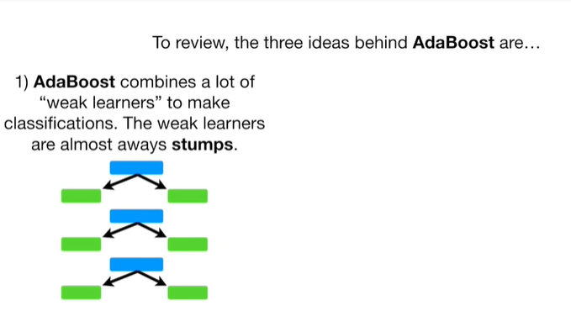

1. Adaboost combines a lot of weak learners to make classifications.

The weak learners are almost always stumps.

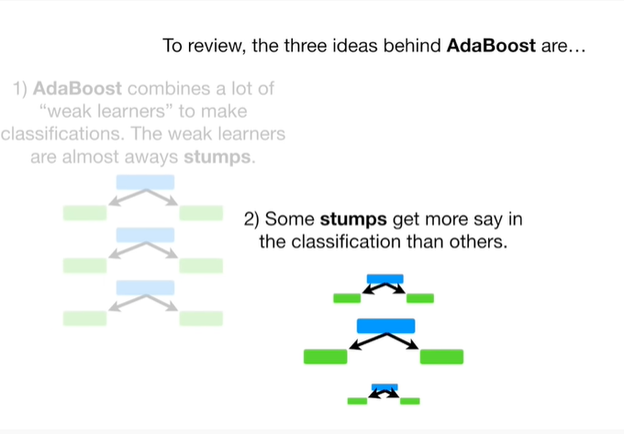

2. Some stumps get more say in the classification than others.

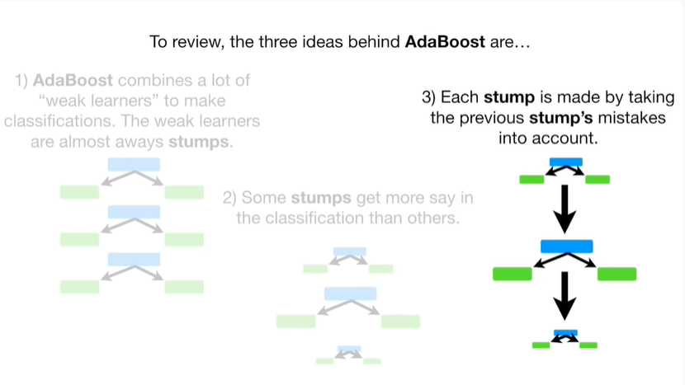

And 3. Each stump is made by taking the previous stumps mistakes into account.

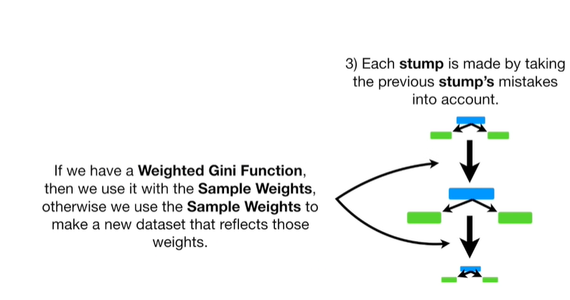

If we have a way to Gini function, then we use it with the sample weights, otherwise we use the sample weights to make a new dataset that reflects those weights.